# 



FACULTY OF SPORTS & TECHNOLOGY

Department of Computing

OCR Cambridge Technicals Level 3



Unit 9 & 11

Paul-David Jarvis



The Littlehampton Academy Sixth Form Registration System

Table of Contents

**Task 1** **7**

Report on Methodologies 7

Product Development Methodologies 7

Waterfall 7

Spiral 8

Incremental 9

Agile 9

Conclusion 10

Time 11

Financial 11

Regulation 11

Standards 11

The need for compromises 12

System Development Methodologies 12

Waterfall 12

Spiral 13

Rapid Application Development 14

**Task 2** **16**

Requirements 16

Computer Requirements 16

Thin Client - Citrix 16

Thick Client - Desktop Computers 17

Software Requirements 18

Interview Questions for Internal/External Stakeholders 18

Questions To Ask Internal Stakeholders 18

Questions To Ask External Stakeholders 18

Information we already know 19

Final Specification 19

Fat Clients 19

Thick Clients 20

Mac 20

Evaluation Critera 20

Emails 22

First Email 22

Second Email 23

Third Email 23

Fourth Email 24

Fifth Email 26

Sixth Email 26

Alternatives for Backend 28

Microsoft Access 28

Microsoft Excel 28

Structured Query Language (SQL) 29

MySQL 29

SQLite 30

Microsoft SQL Server 30

Hosting Sites 31

First Meeting 31

First Meeting Report 32

Second Meeting 32

Second Meeting Report 33

Powerpoint Pitch 33

Backend Alternatives 33

Form Plans 34

Evaluation Criteria 37

Entity Relationship Diagram 38

Data Flow Diagram 38

Class Diagram 40

Use Case Diagram 41

First Objective 41

Second Objective 42

Third Objective 42

Fourth Objective 42

Student Report 43

Student Report 43

First Slide 44

Second Slide 44

Third Slide 44

Fourth Slide 44

Last Slide 44

Frequently Asked Questions 44

Form Plans 45

Login Form 45

Student Form 45

Staff Form 47

Sign In Form 47

Sign Out Form 48

Emergency Form 48

Database Tables 49

Student Details Table 49

TimeTable Details Table 49

Staff Details Table 50

Sign In Table 50

Sign Out Table 51

Validation 51

Verification Form 52

No Username or Password entered And Username or Password not found in the database 52

Pseudocode 52

Staff Form 52

Student’s First Name Not Entered 52

Pseudocode 53

Sign In Form 53

No Student ID, First Name, Last Name or SixthForm Class entered 53

Pseudocode 53

Sign Out Form 54

No Student ID, First Name, Last Name, SixthForm Class or Reason entered 54

Pseudocode 55

Issues Encountered 55

Third Meeting 59

Third Meeting Report 59

Video Log 61

Video 1: Validation Methods 61

Video 2: Incorrect Login 61

Video 3: Student Login 61

Video 4: Student Logout 62

Video 5: Students Sign In 62

Video 6: Students Sign Out 62

Video 7: Teacher Login 62

Video 8: Student Filter 62

Video 9: Emergency Form Before Students Sign in 62

Video 10: Emergency Form After Students Sign in 63

Video 11: Emergency Form After Students Signed Out 63

Video 12: Emergency Form Filters 63

Video 13: Emergency Form Print 63

Data Outputs 63

StudentID 63

FirstName 64

LastName 64

SFClass 64

SignedIn 64

SignedOut 65

Smartphone Layout 65

Smartphone 65

Legal Issues 65

Entity Formation 66

Confidentiality 66

Testing Table 67

Testing Log 69

Typing in the wrong username or password 69

Typing in the correct username and password 69

Leave username blank 70

Leave password blank 70

Entering students details 70

Entering staff details 71

Students timetables show on the students form 71

Student Sign In 72

Student Sign Out 73

Testing Plan 73

Internal Stakeholder testing 73

External Stakeholder testing 75

Instructions 75

Staff Instructions 75

Logging In 75

Search For A Student 75

Access The Emergency Form 76

Printing Out 78

Student Instructions 79

Log In 79

Signing In 79

Signing Out 80

Implementation Log 81

07/02/2018 81

08/2/2018 82

09/02/2018 82

10/02/2018 82

11/02/2018 83

13/02/2018 83

14/02/2018 83

16/02/2018 84

26/02/2018 84

27/02/2018 84

01/03/2018 84

05/03/2018 85

06/03/2018 85

09/03/2018 85

10/03/2018 85

12/03/2018 86

14/03/2018 86

Codes & Annotations 86

Verification Form 86

Student Form 89

Sign In Form 90

Sign Out Form 92

Staff Form 94

Emergency Form 95

Target Profiles 96

Student Target Profile 96

Staff Target Profile 97

Form Plan Evaluation 97

User Acceptance Test Plan 100

References **101**

# Task 1

## Report on Methodologies

### Product Development Methodologies

#### Waterfall

Waterfall is a linear method of product development which is the cheapest to develop. It flows in one direction downwards through the phases of conception, initiation, analysis, design, construction, testing, deployment and maintenance. Once the product has been released, it can’t be backrolled. It’s the cheapest, however it’s the most riskiest. If any problem would occur, it would be impossible to backroll the product to a previous working time. An example is with a delivery company and they occur an error in their system which the waterfall method was used, this could have devastating effects as they can’t process their deliveries and their delivery vans could be held up which would lose the company a lot of money. They will need to find out what is causing the error and fix it as this method of development doesn’t have any backups so they can’t just rollback.

The waterfall method would be the best choice to use when building our product. The clients have a lack of knowledge which will not be a major issue as the waterfall method is simple and easy to use and it’s great for smaller projects which this automatic registration system is.

| Advantages | Disadvantages |
| --- | --- |
| Simple and easy to use. | High risk. |
| Easy to manage. | Poor method for long projects. |
| Phases don’t overlap. | No working software until late in the phases. |
| Works for smaller projects. | Not a suitable model for projects with high probability of change. |

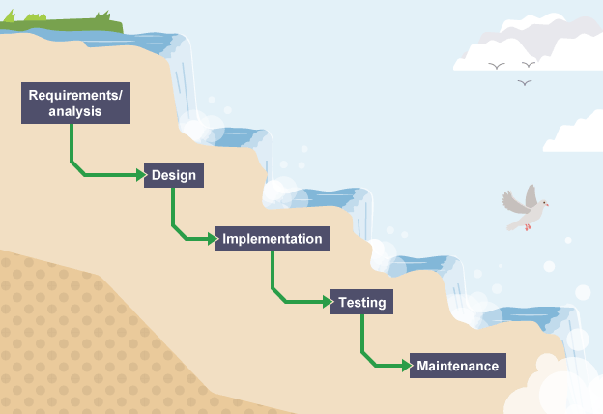

#### Spiral

Spiral is more expensive than the waterfall method as when each little development is made, the software is updated and can be backrolled if any problems arise. The advantages of using a spiral model is that risk avoidance is high, it’s good for large and mission critical projects, allows a large control of documentation, additional functionality can be added later. The disadvantage is that it’s very expensive, it requires highly specific expertise, the project success is highly dependent on the risk analysis phase and it doesn't work well with smaller projects. An example of the problems that could be caused is similar to the example given on the waterfall method. However the delivery company was able to backroll their delivery system to a previous working update which would save them a lot of money.

| Advantages | Disadvantages |
| --- | --- |
| High amount of risk analysis. | Expensive. |
| Additional functionality can be added later. | Requires high expertise. |
| Good for large missions. | Doesn’t work well for smaller projects. |
| Software is produced early. | Overall success is highly dependent on the risk analysis phase. |

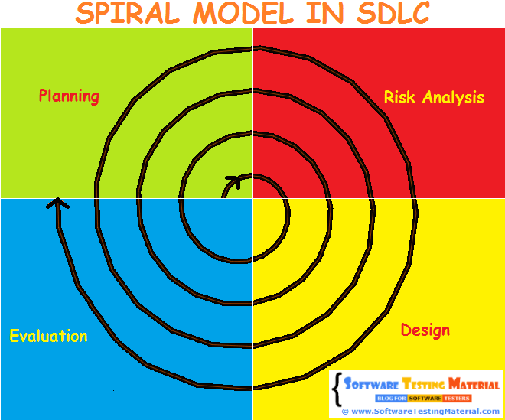

#### Incremental

The Incremental model is a linear development method where the product is designed, implemented and tested incrementally and little changes are added. Each time an increment is added, it provides more functionality to the customers. The system is broken down into many mini projects. Advantages to this is that errors in the software can be seen during each iteration and quickly sorted. It is easier to test and debug than the Spiral and Waterfall methods. Customers can respond to the features and review the product for any needed or useful changes and the initial product delivery is faster and less expensive. Disadvantages are that it can be very expensive and problems may arise due to the system which was not seen in earlier prototypes.

| Advantages | Disadvantages |
| --- | --- |
| Easier to test and debug. | Planning and design needs to be detailed. |
| Lower initial delivery cost. | Total cost is higher than the waterfall method. |
| Easier to manage risk. | Customers can respond to each build. |

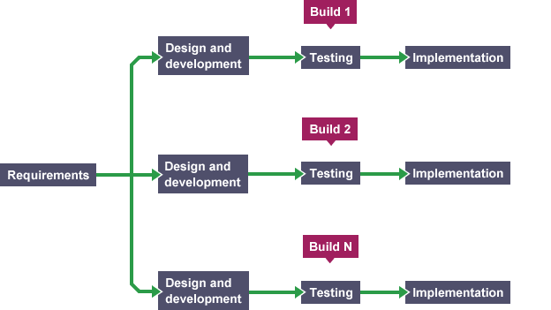

#### Agile

Agile Development is an agile method of product development which is similar to incremental where the product starts with the initiated project and is developed and more functionality is added. After each function is added, the program is integrated and tested. After a few development stages the product is released for feedback to be given and then the product is either accepted and released to the market or it’s set back around a cycle of development stages again.

| Advantages | Disadvantages |
| --- | --- |
| Useful software is released commonly. | The project can easily get taken off track. |
| Continuous attention to technical excellence. | Requires high experience. |
| Regular adaptation to changing circumstances. | Difficult to assess the requirements. |
| Can have changes late in the method. |  |

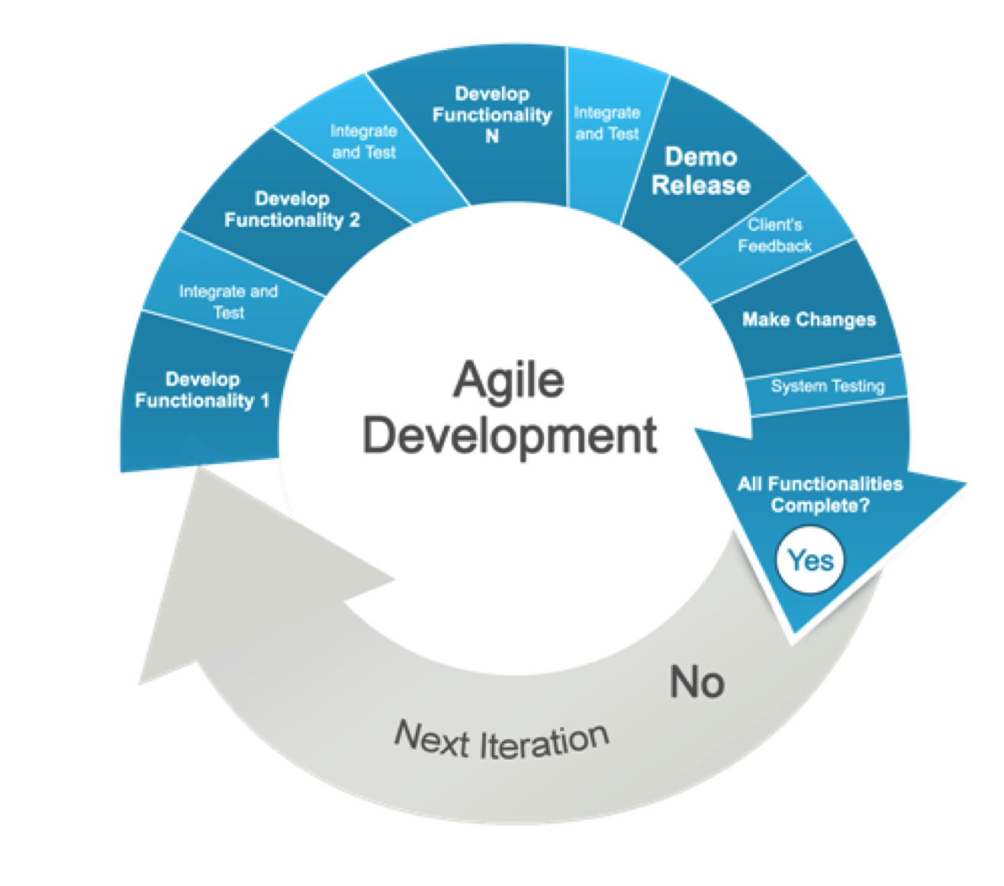

#### Conclusion

To summarise all the product development methodologies. Waterfall is the cheapest however it involves the most risk. The spiral method is more expensive than the waterfall method and dramatically reduces the risk involved in the waterfall method, It requires highly skilled workers and depends massively on sorting out the problems in the risk analysis phase. The incremental model is more expensive than both spiral and waterfall methods but is safer as errors and bugs are fixed faster and more efficiently than the other methods. Lastly the agile method which is similar to the incremental method which is developed and a beta is released to be tested to find bugs, after this the product is either released or sent back around the cycle. Taking into consideration that a school wants a product. It might be a better idea to use either waterfall or spiral method as they’re the cheaper options which is a massive constraint as they’re less likely to have as big a budget as companies like Microsoft or Apple.

There are several constraints that affect the development of a system.

* Time
* Financial
* Social (e.g. language, text types)
* Regulation (e.g. company codes of practice, governmental regulation, national and international law)
* Standards Organisations (e.g. ISO, EN, BS, IEEE)
* Standards (Safety, Design, Quality Management, Risk Analysis, Reliability)
* The need for compromise (e.g. cost/benefit trade-off, complexity/error trade-off, )

##### Time

Time is a huge reason why some projects fall through. Most projects have a strict time frame where they must develop the working and finish system before, however because of unforeseen circumstances they happen to fall behind and are unable to finish the project within the time frame.

##### Financial

Financial reasons are another massive reason why projects fail. Developing a huge and complex system such as a banking system will most likely require a huge budget that will cover the software and the programmers who are working on the system. An example of this is the project TAURUS (Transfer and Automated Registration of Uncertified Stock) It is an electronic trading platform that started in the 1980s and terminated in 1993. The expected cost was £75,000,000 however the project was cancelled due to cost overrun.

##### Regulation

When designing a software you must make sure that you are following all regulations that you need to. Company codes of practices need to be followed when designing your system, however this will change depending on the company you’re designing it for. Governmental regulations such as the Data Protection Act must also be followed as breaking this would result in a fine and legal action.

##### Standards

Standards are also an important constraint that you must tackle. Our project must have a simple design as this is what our stakeholder has requested. The system must also be reliable as our system should provide a snapshot of students in an emergency to check whether any students are in danger.

##### The need for compromises

Cost/benefit trade-off is something we have to consider as our clients (The Littlehampton Academy) don’t have a large budget. This will affect the overall design however we might have to if we are nearing the total of our budget.

### System Development Methodologies

System development methodologies are very similar to the product development methodologies. They have the same development methodologies such as the waterfall method, incremental method, spiral method and the agile method. Instead of a product being developed using these methodologies, it’s a system.

#### Waterfall

The waterfall model is a development approach which the development flows downwards hence the name. Several phases are included in this method however everyone's method is different but the basic development process is there.

* Requirements analysis resulting in a software requirements specification
* Software design
* Implementation
* Testing
* Integration, if there are multiple subsystems
* Deployment (or Installation)
* Maintenance

This method is typically discouraged as you are unable to revisit any prior phase. Critics has gone on to say that this method is to be blamed for several government projects running over their resources such as time and money, in addition to running over their budgets they sometimes fail in delivering the requirements. This is an important problem as projects that could use this method could be extremely vital. In our case we have been tasked with developing a registration system that will take over their previous paper based system, one of the requirements we had been given is the system must be able to provide a snapshot of the students with the details regarding whether or not they have signed out. If this system were to fail on this occasion, we would be unable to tell if any students are still in the burning building.

This would be a decent method that we could use during our development of our project. It is relatively cheap which helps out our client, however this is an important system and would need to be functional and detailed which could cause a problem as we are unable to revisit the previous stage.

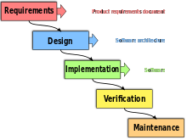

#### Spiral

The spiral method published by Barry Boehm in 1988. It has been combined with some of the key aspects of the waterfall method in an attempt to combine the advantages of the top-down and bottom-up concept which is the strategic information processing and knowledge ordering. The main advantage is that the spiral method has provided a more thorough investigation into deliberate iterative risk analysis.

The basic principles of the spiral method is that it focuses more on risk assessment and minimizing risk by breaking the project into several smaller segments which provides a more ease-of-change during the development process. In addition to this it provides the opportunity to weigh and evaluate risks and consideration of the projects continuation throughout the life cycle.

The spiral method sends the project around the spiral and same sequence of steps several times in order to provide a more thorough development process. The method is split into quadrants: the first is to determine objectives, alternatives and constraints of the iteration. The second quadrant is to evaluate alternatives, identify and resolve risks. The third quadrant develops and verifies deliverables from the iteration and the final is planning the next iteration.

Spiral is a good development method as the system will be analysed and investigated thoroughly with prototypes being developed at the second quadrant. However this method requires high expertise and can be an extremely expensive model to use which our clients don’t have.

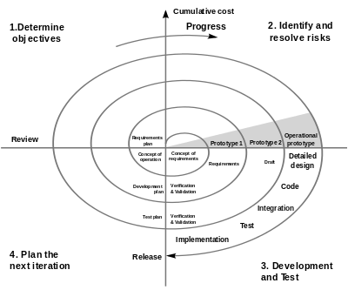

#### Rapid Application Development

Rapid application development of RAD for short is another software development methodology which focuses on the rapid construction of prototypes with a small amount of planning upfront. The lack of planning allows the software to be written a lot faster and generally makes it easier to change the requirements needed.

The method starts with the development of preliminary data models and process models using structured techniques. The next stage is where those requirements are verified by building prototypes of the system and eventually refining those data models.

The basic principles of RAD are to develop the prototypes fast while delivering a high quality system at a low cost. They use several tools such as Graphical User Interface builders, Computer Aided Software Engineering tools, Database Management Systems etc to produce high quality systems quickly. It produces production software as opposed to a throwaway prototype and requires active user involvement.

RAD produces high quality systems at an extremely low price and extremely quickly so this would be a good development method to use when building our system, however the low level of planning could disrupt the process as we would need to speak to our stakeholders and find out what objectives and requirements we need to produce. We would be unsure of any additional requirements that we need.

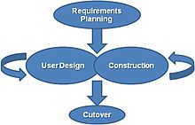

# Task 2

## Requirements

### Computer Requirements

We know that The Littlehampton Academy are running thick client computers and that the operating system (OS) on those computers are running Windows 7. We also know what the minimum hardware requirements are for the OS which are:

* Processor - 1 GHz x86-64
* Memory (RAM) - 2 GB
* Graphics card - DirectX9 graphics processor with the Windows Display Driver model 1.0
* Storage - 20 GB

We are also aware of the components that The Littlehampton Academy computers hold and they meet the minimum requirements.



#### Thin Client - Citrix

The processor that the thin client has is an Intel ® Xeon ® E5520. This is part of the Legacy Intel ® Xeon ® E5 family and is a server central processing unit (CPU). It is a quad-core cpu that runs at a base frequency of 2.27 GHz and supports the LGA 1366 socket. The thin clients have 3 GB RAM.



#### Thick Client - Desktop Computers

The processor that the computers are using is an Intel ® Core™ i3-2120. This is part of the legacy Intel ® Core™ family and is a desktop cpu. It is a dual-core cpu that runs at a base frequency of 3.3 GHz and supports the LGA 1155 socket. This processor has Intel ® HD graphics 2000. The thick clients have 8 GB RAM.

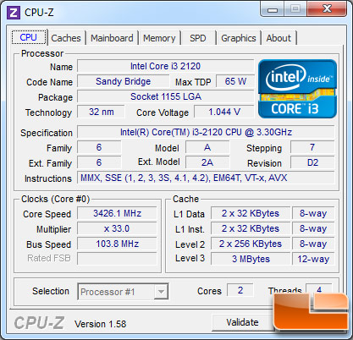

### Software Requirements

The Littlehampton Academy already have the software that they need installed. They have Microsoft Office Professional Plus 2016 installed. They need the Microsoft Access Database Engine for 2010 installed as this will give us the Object Linking and Embedding (OLE) provider as this software component enables an OLE DB consumer to interact with a data source. The clients have asked for the results from the emergency menu to interact and share data with GO4SCHOOLS which they already have installed.



## Interview Questions for Internal/External Stakeholders

### Questions To Ask Internal Stakeholders

Q1: What is the expected timeframe for this project?

Q2: What is the expected budget for this project?

Q3: How Would the TLA Sixth Form students use this system?

Q4: What are you expecting from this system?

Q5: What problems will this new system solve?

Q6: What inputs will this new system ask for?

Q7: What information would like to be imported from your other systems?

Q8: Who would be using this new system?

Q9: What kind of Student Management systems do you prefer?

### Questions To Ask External Stakeholders

Q1: How will this system benefit you?

Q2: Is there anything you want this system to show or do?

Q3: Do you have a mobile phone?

Q4: Do you use the current paper based system?

Q5: What do you find annoying about the paper based system?

Q6: Do you think there is a need for a new system?

### Information we already know

Pastoral staff wants a simple to use and easy to maintain computer program.

The system should ask for the student’s name, sixth form class and reason for leaving college.

There are seven registration classes and each has a tutor (SF1-SF7).

The clients do not know an awful lot.

The school has a network services team of four.

It must be compatible with a windows based network, used to inform assessment for individual students and can provide a list of students who are still in school in an emergency.

The school systems are windows 7 PCs, thin client Citrix systems as well as additional laptops and tablets.

## Final Specification

The final system is a registration system for Sixth Form students. It has a Visual Basic front end and a Microsoft Access back end. It will have several forms for both students and staff. Students will have their own form as well as having access to a form dedicated for signing in and out. Staff members also have their own form as well as having access to a form dedicated for emergencies.

The system will be run primarily on Windows computers with the exception of the Macs around the school in the rooms for media. The system will also be run on android and IOS as this will allow students to run the system on their smartphones. Including all these different operating systems and platforms, this system can also be run on Citrix.

This system will require a low specification PC to run. There are several different types of computers within The Littlehampton Academy and they’re all running different hardware. These computers can be seen below.

To run the project efficiently it would require several software. The system has a back end of Microsoft Access which would require a valid license for Microsoft Office, a front end of Visual Basic which then requires a license for the program. The stakeholder requested that the data could be exported into SIMS or GO4SCHOOLS. Citrix is also needed as it can be used to run the system on.

### Fat Clients

Operating System: Windows 7

Processor: Intel ® Core™ i3-2120 - 3.3 GHz

Memory: 4 GB - 8 GB

Motherboard: LGA 1155 socket

Graphics: Integrated

### Thick Clients

Operating System: Windows 7

Processor: Intel ® Xeon ® E5520 - 2.27 GHz

Memory: 3 GB

Motherboard: LGA 1366 socket

### Mac

Operating System: OS X 10.9.4

Processor: Intel Core 2 Duo - 2.4 GHz

Memory: 4GB

Motherboard: LGA 775 socket

Graphic: ATI Radeon HD 2400 XT 128 MB

## Evaluation Critera

Below is a table that holds the objective numbers, the objectives and a testing method to see to what extent they have been met.

| Objective # | Objective | Testing Method |
| --- | --- | --- |
| 1a | The system will recognise and distinguish who the user is and whether they’re a student or staff member.  For the student to be directed to the students form. This is done by defining the student using an SQL statement.  For the staff to be directed to the staff form. This is done by defining the teacher using an SQL statement. | The objective would be fully met if the users are directed to the correct form for their type.  The objective would be partially met if only a few users are directed to the correct screen.  The objective would not be met if it is not directed to any of the correct screens or there is no valid way to recognise the users. |
| 1b | The user will be able to log in using a username and password. | The objective would be met if the user are able to login using their username and password.  The objective would not be met if the user is unable to login using their username and password. |
| 2a  2b  2c | The system which could be used to check whether any students are still in the building in an emergency situation.  The report that would be produced in this situation could be sorted into tutor groups.  The report can be sorted using a variety of filters such as firstname, surname in alphabetical order. | The objective would be fully met if the staff can access the emergency menu, sort the students by tutor and other filters.  The objective would be partially met if the teacher can access the report and isn't sorted.  The objective would not be met if the report is not produced. |
| 3a | The system will record students signing in and out.  For the system to store the following information about the students details regarding the signing in and out.   * First Name * Last Name * SixthForm Class * Signing In Time * Signing Out Time * Reason | The objective would be met if the information entered by the user is saved to the specific tables. |
| 4a | The students timetable will be shown when the student logs on. | The objective would be met if the student’s timetable displays when they log on.  The objective wouldn’t be met if no timetable is shown or all timetables are shown. |

## Emails

### First Email

The first email was sent on the 1st March 2018, 14:52. This email was sent to Mr. Garner, one of the technicians that we discussed the inner workings of our project. We were discussing potential solutions to a problem encountered regarding the Microsoft.ACE.OLEDB.12.0 library. We sent Mr. Garner several different solutions to this problem: we could’ve downloaded the DLL library from the Microsoft website, we could’ve used Citrix, we could have updated a laptop with the library. We decided to go with the second solution as this would’ve been easier for everyone involved and have easier access.

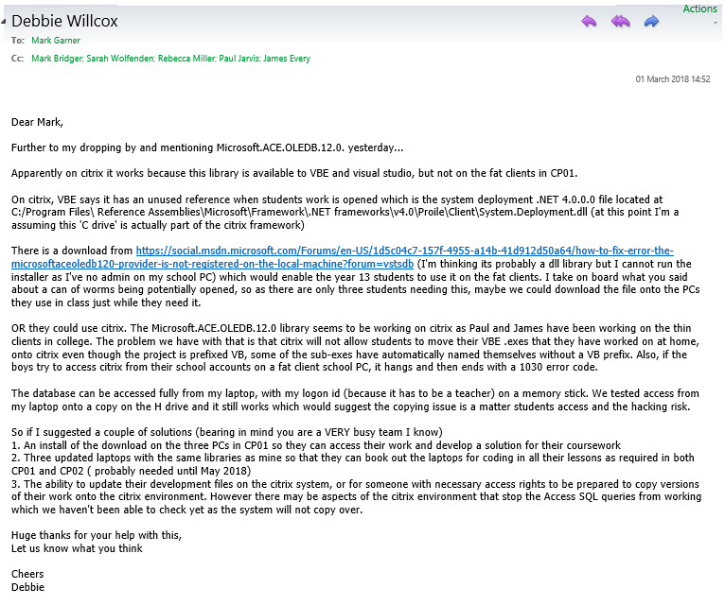

### Second Email

The second email was to both Mr. Bridger and Mr.Garner, this was to confirm that the library was installed on a single computer to allow us to test whether or not the dll library works on the fat clients. They offered to install the library on the rest of the computers if it works on the single computer that they installed it on.

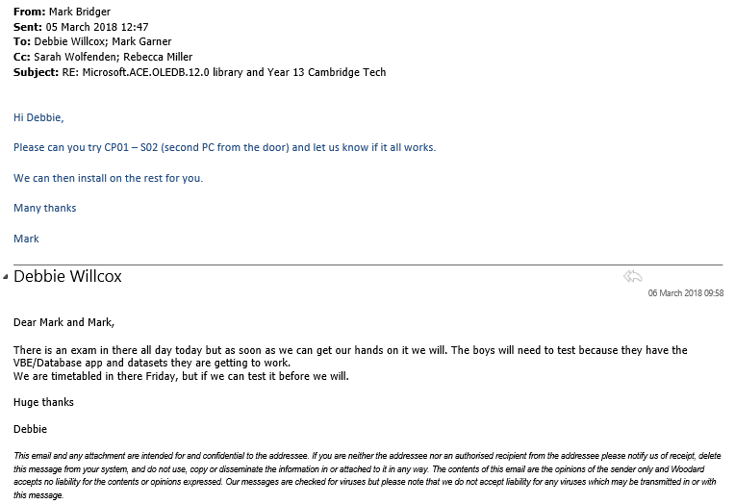

### Third Email

The third email is to both Mr. Bridger and Mr.Garner, This was in reply to the potential solutions discussed in the first and second email. We investigated the solutions and found out that the library that was installed doesn’t work on the fat client PC as expected, we also discovered that it works on Citrix and it works on a laptop with higher access rights. We discussed the possibility of increasing our access for a short amount of time, we saved the project in a folder and allowed Mr. Bridger to play around with it to discover the root of the error.

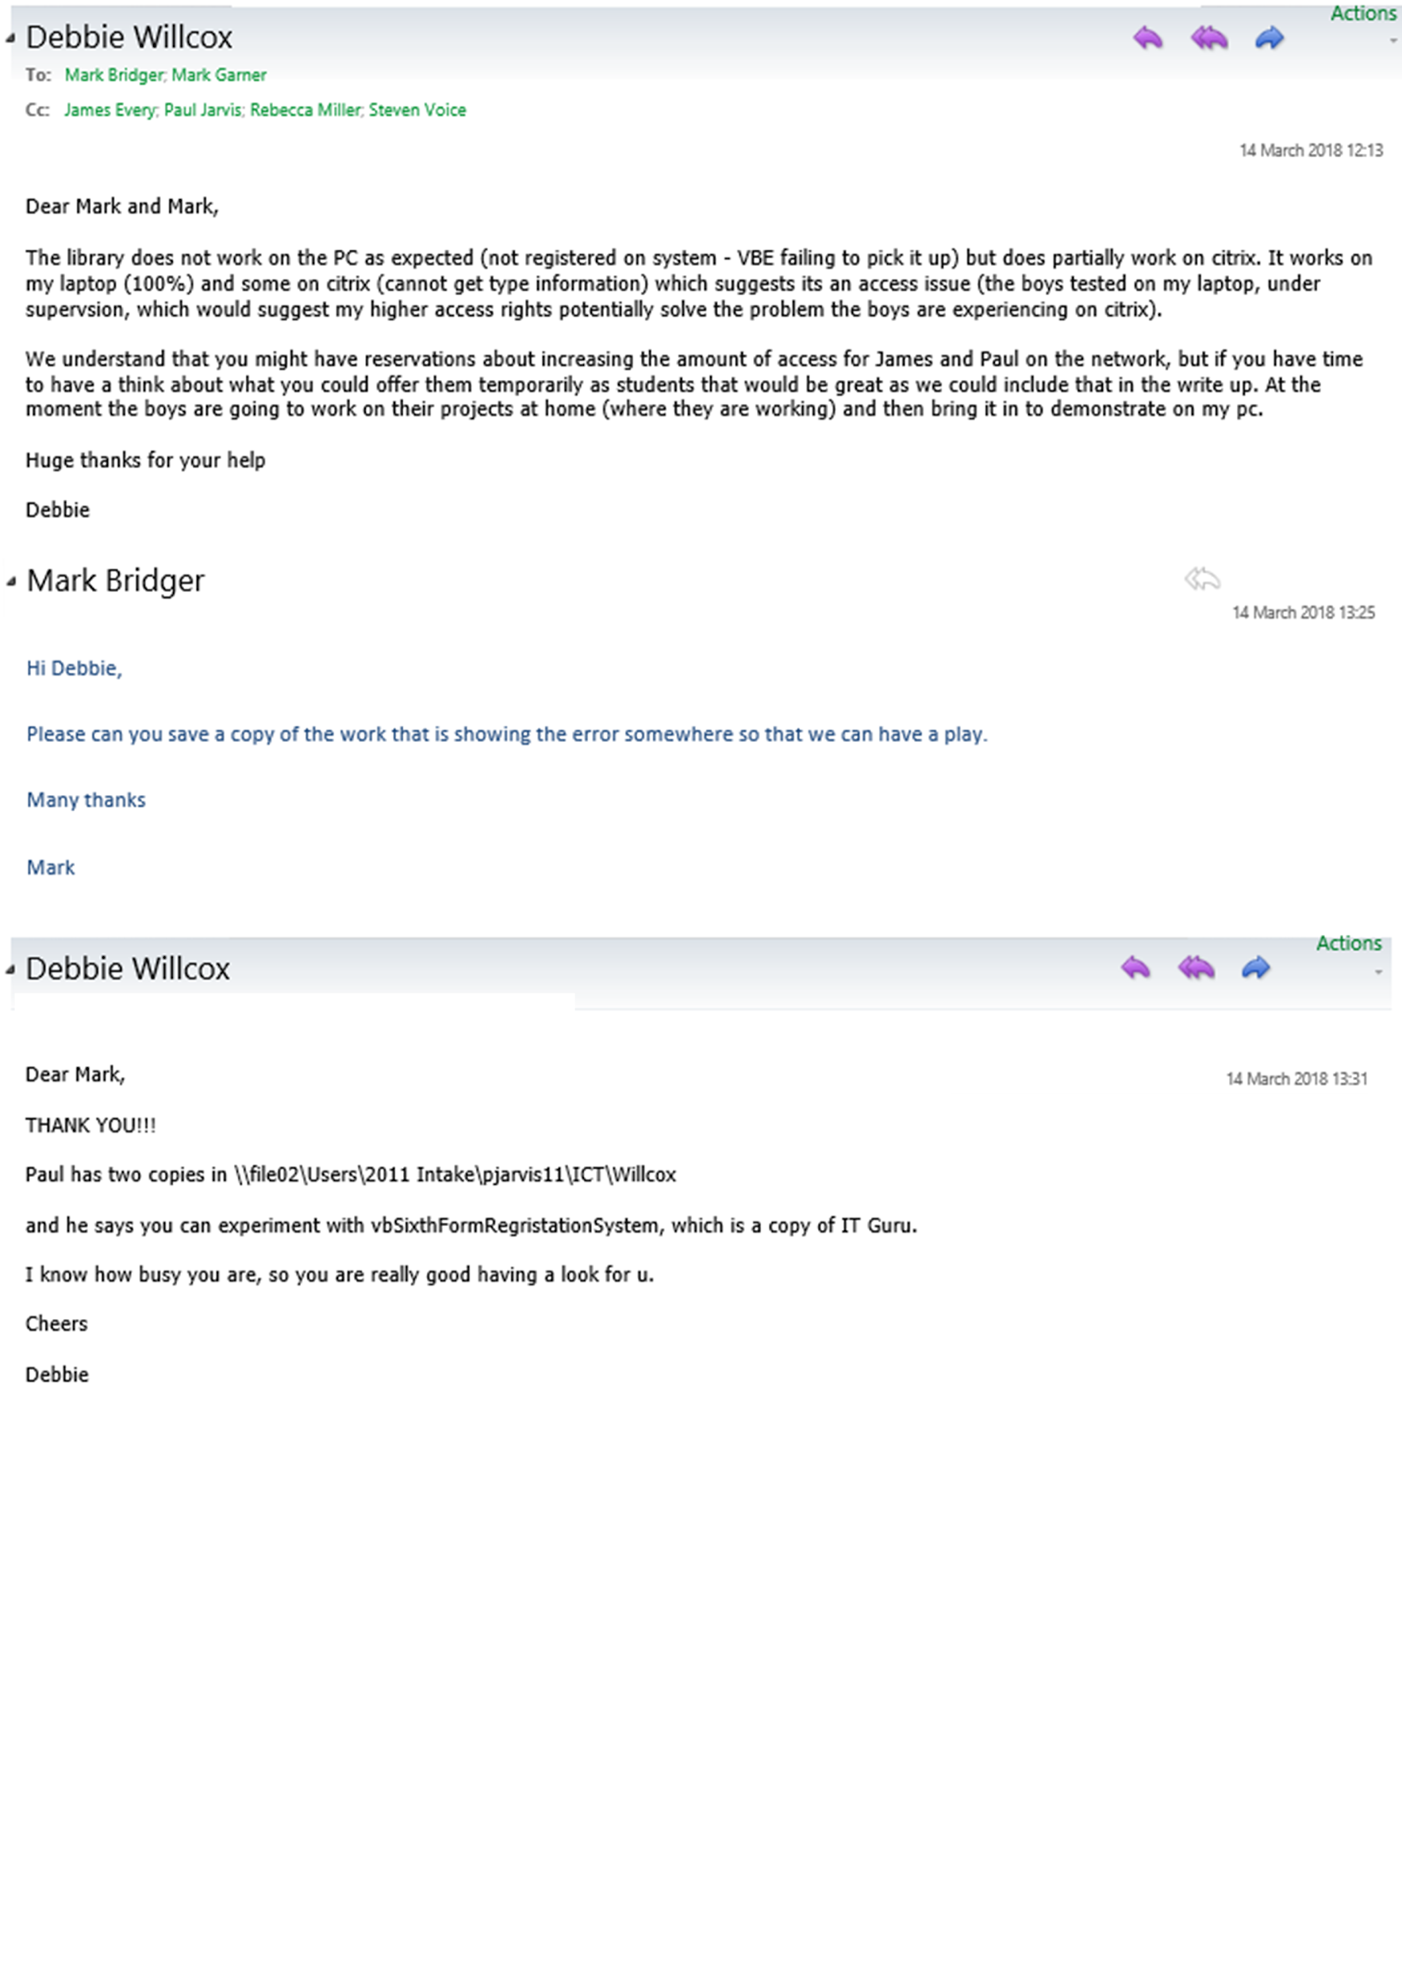

### Fourth Email

The fourth email was to Mr. Garner, we were discussing the possibility of building the project on a home computer and transferring it to one of the school's computers. I went and saw Mr. Garner who transferred my project from a USB thumb drive to my H: drive. I mentioned that I kept receiving a cache error which Ms. Willcox offered a solution in which I replied.

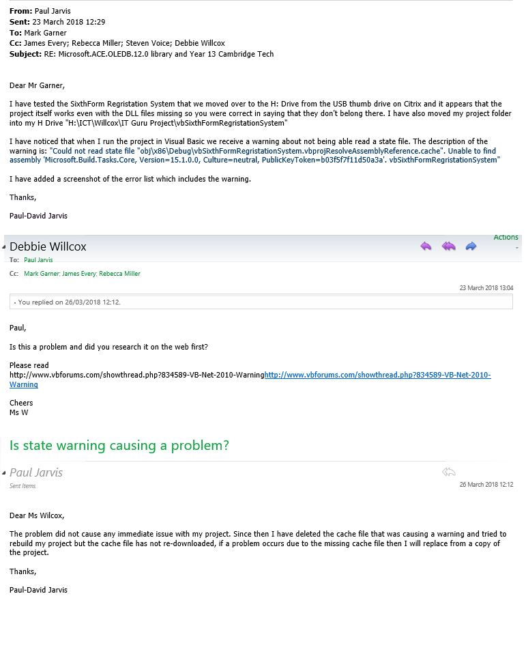

### Fifth Email

The fifth email was to our stakeholder asking for a final meeting so I can show him the work I’ve done since the second meeting. I received a reply at 21:51 confirming a brief meeting the day after to discuss a time for the final meeting. The final meeting will be on the 14th May, 11:30.

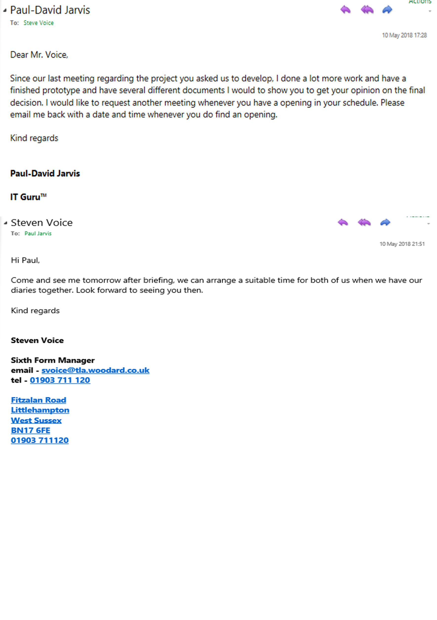

### Sixth Email

The sixth email is discussing with our stakeholder different alternatives than using Visual Basic. We discussed using Google Spreadsheets, however he decided to go with the Visual Basic program as using Google Spreadsheets requires the usage of macros which is extremely annoying to program and script them.

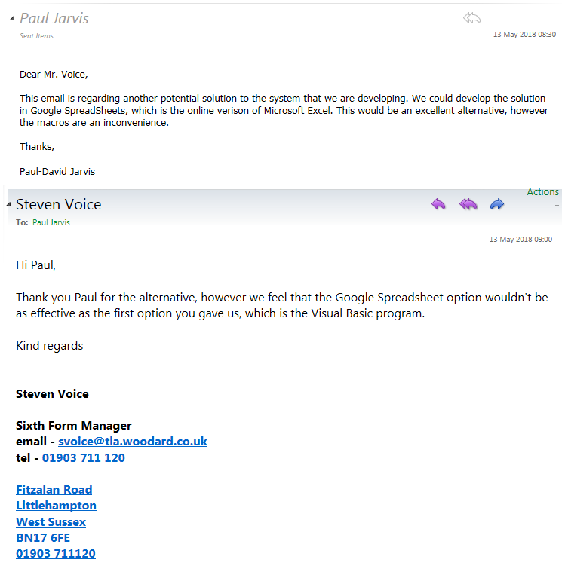

## Alternatives for Backend

### Microsoft Access

Microsoft Access is a database application that integrates forms, tables, queries and more. It is highly effective when dealing with large quantities of data as each table can be linked using a primary key and a foreign key. Which makes it extremely easy to filter large amounts of data. There are many alternatives that could be used instead of Microsoft Access however Microsoft Access is cost effective and easy to use. It can be used to create a database that can help run this project. The data can also be stored in a cloud database so it can be backed up and shared with colleagues. It has many great templates that allow us to develop the package quickly and efficiently.



### Microsoft Excel

We also have Microsoft Excel which is another great application, however Excel is used for spreadsheets. There are many features on Excel such as the macros and formulas that allow for easy calculations such as two cells added together, finding the average of both cells etc. Excel also includes many templates that can make the users time easier. Spreadsheets can also be stored onto the cloud which can be shared with colleagues.



### Structured Query Language (SQL)

This is a language that is used in programming and designed for managing data held in databases. The use of SQL Syntax and commands can perform several functions. SQL can do many things which is shown below and sourced from W3Schools.

* SQL can execute queries in a database
* SQL can retrieve data from a database
* SQL can insert records into a database
* SQL can update records in a database
* SQL can delete records from a database
* SQL can create new databases
* SQL can create new tables in a database
* SQL can create stored procedures in a database
* SQL can create views in a database
* SQL can set permissions on tables, procedures, and views.

SQL has loads of SQL commands however the most important SQL commands are as follows.

* SELECT - extracts data from a database
* UPDATE - updates data in a database
* DELETE - deletes data from a database
* INSERT INTO - inserts new data into a database
* CREATE DATABASE - creates a new database
* ALTER DATABASE - modifies a database
* CREATE TABLE - creates a new table
* ALTER TABLE - modifies a table
* DROP TABLE - deletes a table
* CREATE INDEX - creates an index (search key)
* DROP INDEX - deletes an index

SQL also has several management softwares. They all perform the same function and are used for the same thing within businesses, they help manage large amounts of data. However using SQL to store your information must require a server host.

#### MySQL

MySQL is an extremely popular application for storing information. Their customers are extremely successful and they rely on them to save time and money to power their websites, packaged software and critical systems. Below are some of the world’s largest and fastest growing organizations.

* YouTube
* Paypal
* Google
* Facebook
* Twitter
* Ebay
* Linkedin
* Uber
* Tesla
* Netflix
* H&M

MySQL has many different software editions which gives the customer a wide choice and allow them to pick the best package to suit their needs.

* MySQL Editions
* MySQL Enterprise Edition
* MySQL Standard Edition
* MySQL Classic Edition
* MySQL Cluster Carrier Grade Edition
* MySQL Embedded



#### SQLite

SQLite is also another SQL software that helps sort large information easily. SQLite is another relational database management system contained in a C programming library. There is one big difference that SQLite has over other SQL management software, SQLite is not a client-server database engine. It is embedded into the end program.



#### Microsoft SQL Server

Microsoft also has an application that is used by industries to help big organizations to organize their data by using their SQL Server. Microsoft SQL Server is a relational database management system. Their software product has the primary function of storing and retrieving data.



As previously said SQL is a great language to sort mass information however it requires servers hosts. Microsoft SQL Server 2008 Database Hosting is an excellent host who offers two packages as well as the additional space if required. This is seen below.

* MS SQL Server Lite (100MB): £9.90 per month + vat (or £99 + vat per year)
* MS SQL Server Std (300MB): £14.90 per month + vat (or £149 + vat per year)

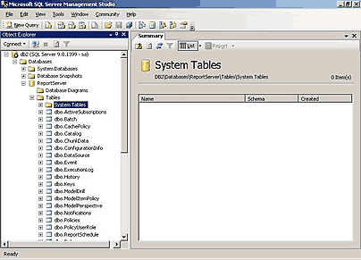

#### Hosting Sites

There are many server hosting sites that offer many packages. This is both an advantage and disadvantage as there are many options which we can cherry pick the best one suited to us and also there are too many which may seem overwhelming to our clients.





## First Meeting

### First Meeting Report

The clients are SIMPLE resources, an educational software team. They approached IT Guru ™ to create a registration system which will be used to monitor sixth form students who’re signing in and out of the college at the sixth form of The Littlehampton Academy. The pastoral staff who were interviewed said that they wanted a simple to use and easy to main application.

The Littlehampton Academy are looking for a product which would ask for the student’s name, student’s class or the reason why they’re signing in or out. They’re also looking for an emergency menu which will allow tutors to retrieve their student’s data from the specific class database to determine if all their students are safe or could be in danger.

The potential solutions presented such as the emergency menu could be improved by using a more refined SQL query that loads the data from the signing in and out tables. The client is looking for an emergency menu that would display the students who have signed in and has not signed out.

Another solution presented for the signing in and out menu two forms that the student is redirected to when they click either the button to sign in or to sign out. These forms will ask the user for his full name, his Sixth Form class and the reason why he is signing out. This could potentially be improved by automatically updating the tables when the student clicks on either button instead of being navigated to another form where they must enter their details. This could be done by using an SQL query that selects all the details from several tables and use the details previously entered such as his username which we can use to link to his record in the table holding all the students data.

The first meeting with our stakeholder was on Monday 19th February at 11:25AM. We discussed the basics of the new system, what the objectives are and what our clients want. During the period of this meeting our stakeholder filled out a questionnaire which gave us extremely vital details regarding the system. Below is a snapshot of some of the questions that were answered during this meeting.

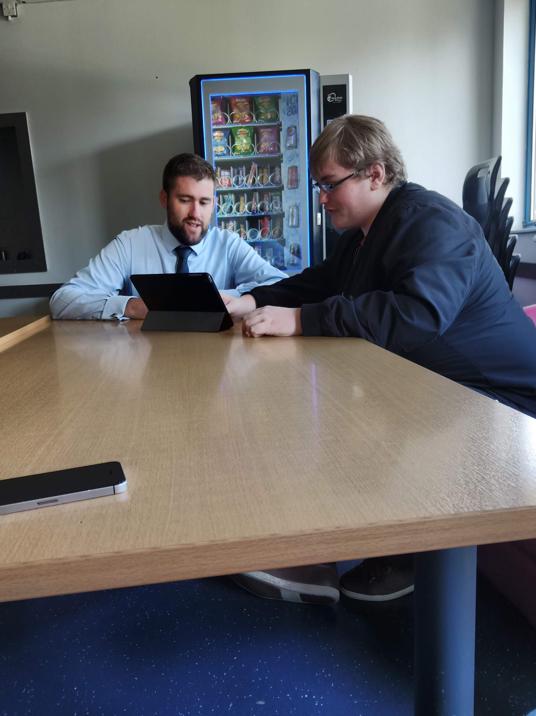

## Second Meeting

### Second Meeting Report

The second meeting on Friday 9th March at 09:00 AM. During this meeting I showed the client several documents to help the client understand our ideas and was able to receive feedback that managed to help us to build a system that is fit for our clients needs.

#### Powerpoint Pitch

The first document I showed our clients was the pitch which was a powerpoint that firstly introduced our system, secondly was the system requirement analysis which identified problems with their original system, took their existing systems into consideration and gave a brief example of the proposed system. We then showed the functional and non-functional requirements we identified. Functional requirements are what the system will do and the non-functional requirements are how they will do it. We then showed some outline solutions to the requirements the clients are looking for. The next slide that was shown was the purpose of the system. The slide after that was a context in which we summarised the things we already know such as their existing systems and their paper based system. Second last was assumptions which are the things that we identified from the scenario such as The Littlehampton Academy running windows 7 and having a Citrix thin client. The last slide on the pitch were the potential constraints that we discovered which were the interoperability with the existing systems, the budget and the long list of alternative programs that we could have used when developing this system.

#### Backend Alternatives

The second document that was shown to our clients were the alternatives that we could have used for the backend to store the data for this system. This went over a variety of programs listing the pros and cons so the client was given a wide range of different programs that we could use. Below is a table of all the programs that we looked at as well as different hosting sites for a SQL database.

* Microsoft Access
* Microsoft Excel
* Microsoft SQL Server
* MySQL
* SQLite
* SQL Server Mart
* Rackspace

#### Form Plans

The third document we showed our client was the form plans. This document showed several different images that showed what these forms would have looked like when they were finished. These images were extremely detailed and extremely analysed in order to show the clients what they’re exactly buying. We received a lot of helpful feedback and managed to cut a few things from the project and edit the forms. There are several different plans for the forms, one has been improved and the others were the original that had been edited in the improved form designs.

From the designs below you can make out several different changes that the stakeholder requested. When a student logs in, it will now only show their timetable and will no longer allow them to search. Another improvement was the Sign in and out buttons added which will redirect the user to where they can register in or out.

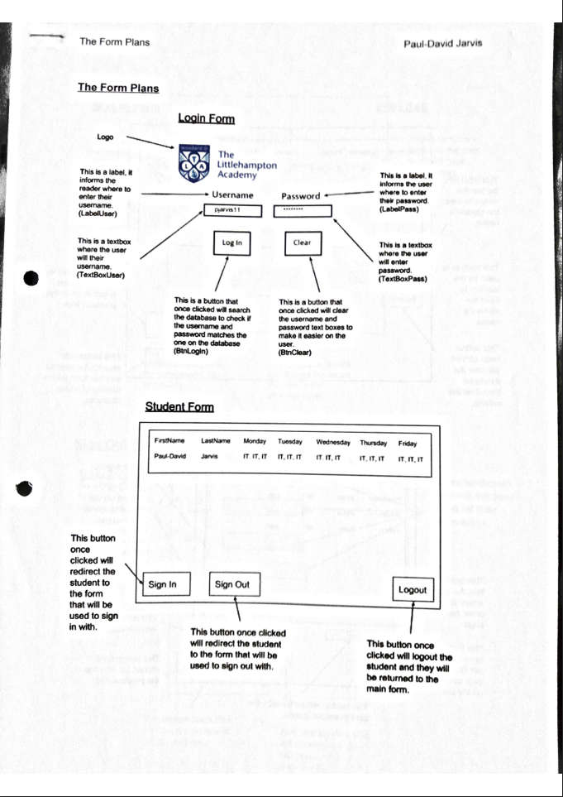

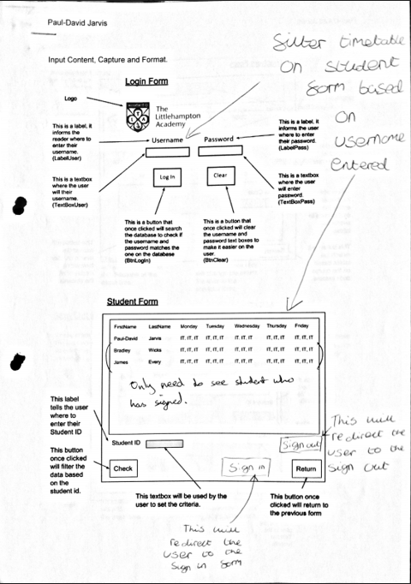

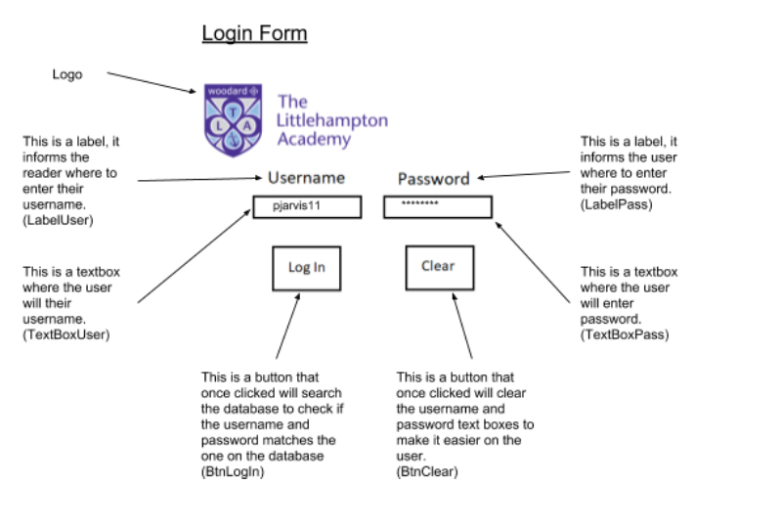

#### Evaluation Criteria

The fourth document to be shown was the evaluation criteria. This document shows the clients what the objectives are and how to test that they work. An example of this is that the system will recognise and distinguish who the user is and whether they’re a student or staff. The use of traffic light statements tell the client how the objective would be fully met, how the objective would be partially met and how the objective would not be met. If the user was redirected to the correct form then the objective would have been fully met, whereas if the user was directed to the correct screen only a few times then it would have been partially met and if the user is redirected to the wrong form then the objective would have failed. We’ve met all the stakeholders requirements.

I also showed the clients four diagrams that were able to give the client an extremely detailed look into the system. I show the client a class diagram, an entity relationship diagram, a data flow diagram and a use case diagram.

##### Entity Relationship Diagram

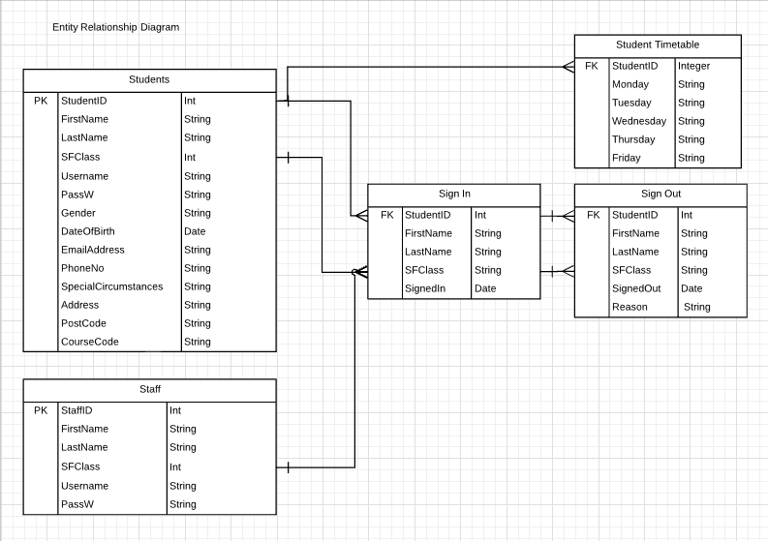

##### Data Flow Diagram

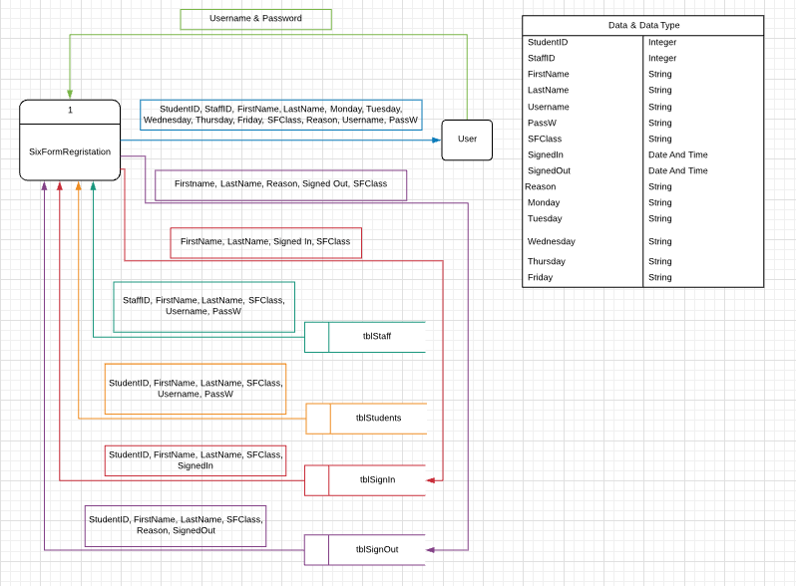

##### Class Diagram

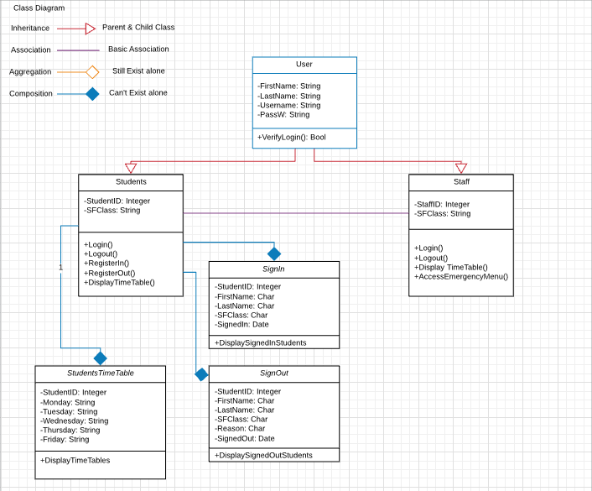

##### Use Case Diagram

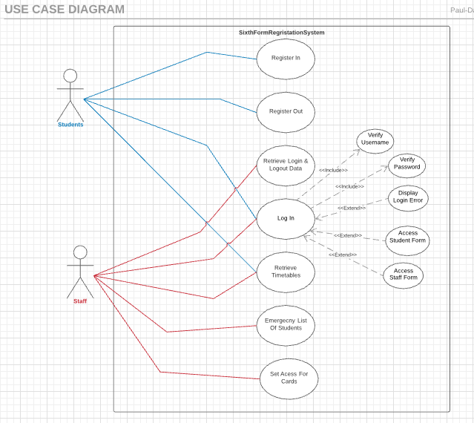

The Littlehampton Academy are in the market for a new system for their Sixth Form College. They want this system to make signing in and out effortless and painless as possible so they hired IT Guru to create this system. We’ve had meetings with the client showing them several documents and diagrams in order to gain as much information as possible. We’ve now come to the conclusion that their existing student management system such as GO4SCHOOLS and SIMS work and the main problem is with students who don’t sign out due to either forgetting or deciding not to, this is where our proposed system comes into play solving these important issues. The improvements we have made are all justified as the updated design models are now in line with our original business requirements.

##### First Objective

The first objective features two different sub-objectives and these are all objectives relating to logging into the system. The table below shows the objective and how our business model works with that objective.

| The system will recognise and distinguish who the user is and whether they’re a student or staff member. | The database that is linked to the project features two tables for students and staff, within this table features username and passwords which are used to login.  The program checks the username and password and which table it is stored in. This is how the system identifies what the user is. |
| --- | --- |
| The user will be able to log in using a username and password. | The user can log into the system using a username and password. They’re able to enter the information in two text boxes. |

##### Second Objective

The second objective is surrounding the emergency form. This objective has three sub-objectives, these can be shown in the table below and how they’re in line with our design model.

| The system which could be used to check whether any students are still in the building in an emergency situation. | The emergency form will only show students who’ve signed in but haven't signed out. This can identify students who are still in the building or at the emergency meet point. |
| --- | --- |
| The report that would be produced in this situation could be sorted into tutor groups. | The emergency form has the option to filter the list by Sixth Form class showing in numerical order. |
| The report can be sorted using a variety of filters such as firstname, surname in alphabetical order. | The emergency form also allows for the staff to sort by selecting the first name or last name option on the filter menu |

##### Third Objective

The third objective is regarding signing in or out. These sets of objectives outline what our system has to do and can be seen and how our design model completes this objective and how it’s in line with the original business requirements.

| The system will record students signing in and out. | The information entered when the student signs in or out is stored to the database in the specific table regarding whether they signed in or out. |
| --- | --- |

##### Fourth Objective

The fourth objective is regarding the timetables. The objective is that when a student logs in then their timetable will show and only theirs. This can be seen in the table below and how our design model is in line with this requirement.

| The students timetable will be shown when the student logs on. | The timetables are stored in a table along with the students username. The student form filters the timetables based on the username entered which is why we included the username in that table. |
| --- | --- |

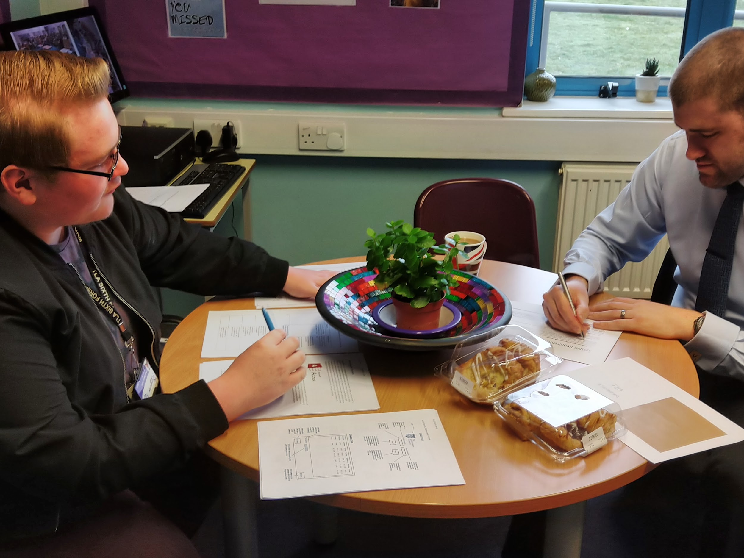

## Student Report

### Student Report

As Well as producing a pitch for our internal stakeholder, I also produced another picture that will be shown to the students of The Littlehampton Academy Sixth Form.

Those students who are products will be used by a large audience will be able to help us develop this program to satisfy everyone. They initially liked the program and the majority said it would be better than what they already have.

#### First Slide

The first slide that was shown was the general idea of this system and the overall goal. We discussed how this system will make their life easier.

#### Second Slide

The second slide we showed was an accessibility slide which can be seen on the image below. This slide featured two pictures of the school grounds showing the previous system where students would have to walk over to the main building and the second picture is the coverage range for our new system. Students enjoyed the idea of not having to walk to the main building in order to sign out.

#### Third Slide

The third slide was the security slide. This slide told the students that they would have to log in with their username and password and what they need to do if they forgot their password.

#### Fourth Slide

The fourth slide was regarding our mobile application. This slide told the students that we actually have a mobile application that is available on several different mobile operating systems so they can sign in or out using their phone.

#### Last Slide

The last slide is the frequently asked questions. This slide showed the questions that are typically asked by students when we discuss this application and the answers to these questions. The questions and answers can be seen below.

#### Frequently Asked Questions

Q: Why can’t I just stay home and register in?

A: This system will only work when connected to the schools or college WiFi.

Q: Why do we need this new system?

A: So many students don’t sign out because they don’t want to walk over to the main building. This system will eliminate that and make it overall easier.

Q: Will I be able to view my timetable from this application?

A: Yes! This application doesn’t only make it easier to sign in and out but when you’re signing in you will be able to see your timetable just before.

This is the kind of meeting that I used to communicate with the year 12 and 13 students to receive feedback on the current system and how we could potentially improve.

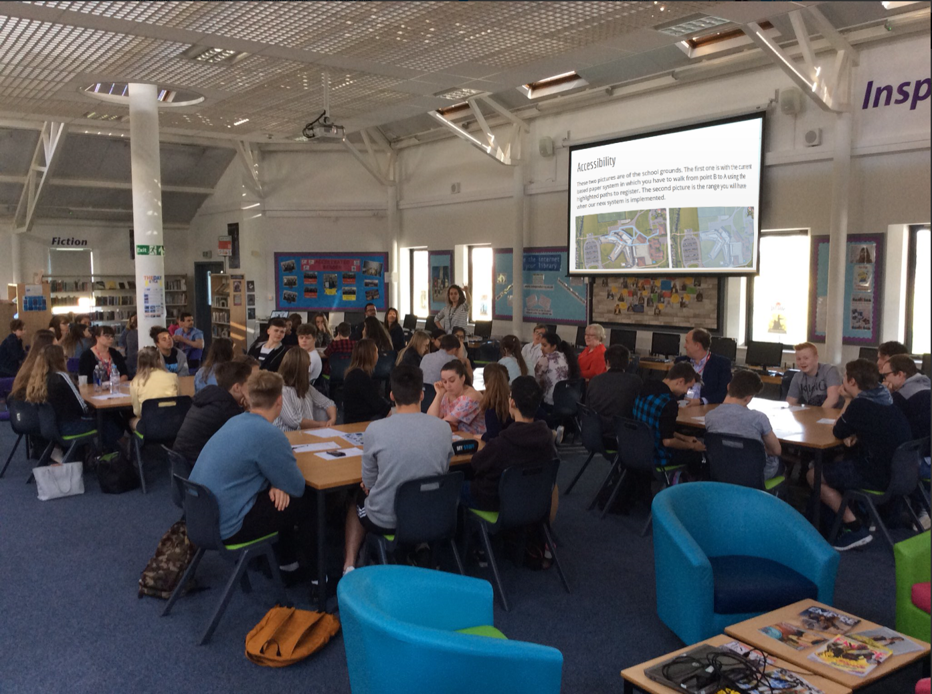

## Form Plans

### Login Form



### Student Form



### Staff Form



### Sign In Form



### Sign Out Form



### Emergency Form



## Database Tables

### Student Details Table

This database will store data in a table for the students details. The fields which will be stored in this table are as follows:

* Student ID
* First Name
* Last Name
* Sixth Form Class
* Username
* Password

| Field Name | Description | Type | Example |
| --- | --- | --- | --- |
| StudentID | The students unique number which can be used to identify them. | Integer | 1135 |
| FirstName | The students' first name. | String | Paul-David |
| LastName | The students' last name. | String | Jarvis |
| SFClass | The students class (SF1 - SF7) | String | SF1 |
| Username | The students username to log in. | String | pjarvis11 |
| PassW | The students password to log in. | String | Password or ***** |

### TimeTable Details Table

This database will store data in a table for the students timetables. The fields which will be stored in this table are as follows:

* Username
* Monday
* Tuesday
* Wednesday
* Thursday
* Friday

| Field Name | Description | Type | Example |
| --- | --- | --- | --- |
| Username | The students username. | String | pjarvis11 |
| Monday | The students' lessons for Monday. | String | IT, IT, IT, IT, IT |
| Tuesday | The students' lessons for Tuesday. | String | IT, IT, IT, IT, IT |
| Wednesday | The students lessons for Wednesday. | String | IT, IT, IT, IT, IT |
| Thursday | The students' lessons for Thursday. | String | IT, IT, IT, IT, IT |
| Friday | The students' lessons for Friday. | String | IT, IT, IT, IT, IT |

### Staff Details Table

This database will store data in a table for the staff details. The fields which will be stored in this table are as follows:

* Staff ID
* First Name
* Last Name
* Sixth Form Class
* Username
* Password

| Field Name | Description | Type | Example |
| --- | --- | --- | --- |
| StaffID | This is the teacher's ID that identifies the teacher. | Integer | 1000 |
| FirstName | This is the teacher's first name. | String | Debbie |
| LastName | This is the teacher's last name. | String | Wilcox |
| SFClass | This is the teacher's class. | String | SF1 |
| Username | This is the teacher's username to login with. | String | dwilcox |
| PassW | This is the teacher's password to login with. | String | password |

### Sign In Table

This database will store data for all the students who have signed in. The fields which will be stored in this table are as follows:

* Student ID
* First Name
* Last Name
* Sixth Form Class
* Signed In

| Field Name | Description | Type | Example |
| --- | --- | --- | --- |
| StudentID | This is a unique ID to identify the student. | Integer | 1135 |
| FirstName | Students' first name. | String | Paul-David |
| LastName | Students last name. | String | Jarvis |
| SFClass | Students Class. | String | SF1 |
| SignedIn | Students date and time of signing in. | Date | 20/02/2018, 9:00AM |

### Sign Out Table

This database will store data for all the students who have signed out. The fields which will be stored in this table are as follows:

* Student ID
* First Name
* Last Name
* Sixth Form Class
* Reason
* Signed Out

| Field Name | Description | Type | Example |
| --- | --- | --- | --- |
| StudentID | This is a unique ID to identify the student. | Integer | 1135 |
| FirstName | Students' first name. | String | Paul-David |
| LastName | Students last name. | String | Jarvis |
| SFClass | Students Class. | String | SF1 |
| Reason | Students reason for signing out early. | String | Doctors |
| SignedIn | Students date and time of signing in. | Date | 20/02/2018, 1:30PM |

## Validation

### Verification Form

#### No Username or Password entered And Username or Password not found in the database

The first validation in our project is checking whether the user has entered his username or password. If the user entered a username but no password they will receive a message box telling them that the system can’t detect a password. However if the user has entered a password and no username they will receive another message box that tells the user that the system can’t detect a username. In addition to this validation we also have additional validation that checks whether the username or password entered matches any records in the database. If none of the records match then the user will receive a message telling them that it was not found otherwise they will be moved to their form.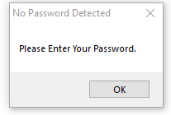

##### Pseudocode

START

INPUT Username, PassW

IF Username is empty

OUTPUT a Message “Please Enter Your Username.”

ELSEIF Password is empty

OUTPUT a Message “Please Enter Your Password.”

ELSEIF Username & Password in tblStudents THEN

Show StudentForm

ElSEIF Username & Password in tblStaff THEN

Show StaffForm

ELSE OUTPUT a Message “Sorry, username or password not found.”

END IF

END

### Staff Form

#### Student’s First Name Not Entered

This piece of validation checks whether a staff member searching for a student has entered the student’s first name. This doesn’t check whether the is a student with this name but checks whether the textbox used for entering the student’s name is empty. If the staff member tries to search for a student without entering a name then they will receive a message box telling them that they haven’t entered anything.

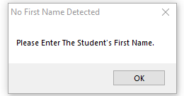

##### Pseudocode

START

INPUT FirstName

IF FirstName is empty

OUTPUT a Message “Please Enter Your Username.”

ELSE Filter DataBase

END IF

END

### Sign In Form

#### No Student ID, First Name, Last Name or SixthForm Class entered

The signin validation in our project is checking whether the user has entered his details: Student ID, First Name, Last Name and SixthForm Class. The user will receive messages telling them that they have not entered that certain piece of information if this is true else the information he entered will be saved.

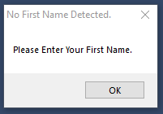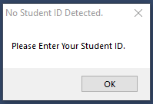

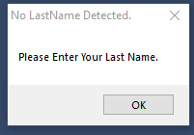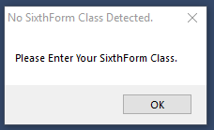

##### Pseudocode

START

READ tblSignIn, tblSignOut

INPUT StudentID, FirstName, LastName, SFClass

IF StudentID is empty

OUTPUT a Message “Please Enter Your StudentID.”

ELSEIF FirstName is empty

OUTPUT a Message “Please Enter Your First Name.”

ELSEIF LastName is empty

OUTPUT a Message “Please Enter Your Last Name.”

ELSEIF SFClass is empty

OUTPUT a Message “Please Enter Your SixthForm Class.”

ELSE Save details to DataSet

END IF

END

### Sign Out Form

#### No Student ID, First Name, Last Name, SixthForm Class or Reason entered

The signout validation in our project is checking whether the user has entered his details: Student ID, First Name, Last Name, SixthForm Class and Reason. The user will receive

messages telling them that they have not entered that certain piece of information if this is true else the information he entered will be saved.





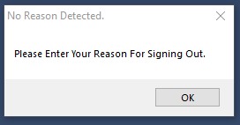

##### Pseudocode

START

READ tblSignIn, tblSignOut

INPUT StudentID, FirstName, LastName, SFClass, Reason

IF StudentID is empty

OUTPUT a Message “Please Enter Your StudentID.”

ELSEIF FirstName is empty

OUTPUT a Message “Please Enter Your First Name.”

ELSEIF LastName is empty

OUTPUT a Message “Please Enter Your Last Name.”

ELSEIF SFClass is empty

OUTPUT a Message “Please Enter Your SixthForm Class.”

ELSEIF Reason is empty

OUTPUT a Message “Please Enter Your Reason For Signing Out.”

ELSE Save details to DataSet

END IF

END

## Issues Encountered

We encountered several problems in the planning stages of this project. Firstly we couldn’t connect to our Microsoft Database as we were missing the database engine and provider and we didn’t have permission to install the engines.

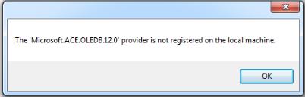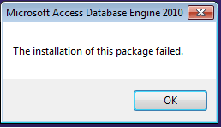

We investigated thoroughly into the properties of our Visual Basic project to check the references to see if the Microsoft OleDB 12.0 was unused. However during the investigation I noticed that the database engines were installed on the Sixth Form thin clients and Citrix without being referenced.

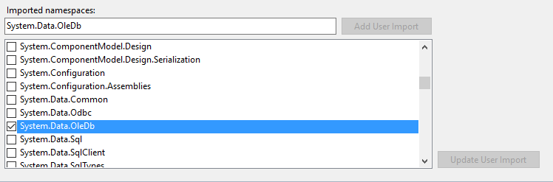

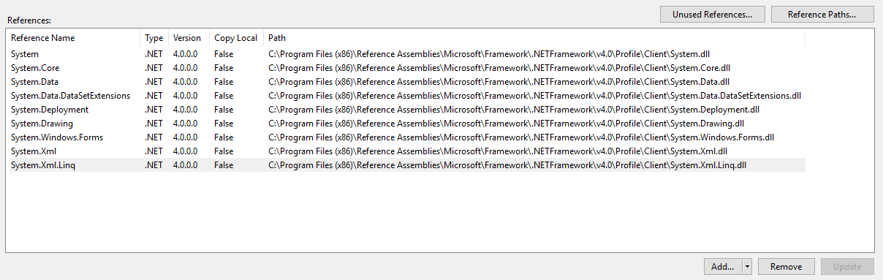

When we attempted to create datasets from data sources on our Visual Basic project, we kept receiving an error telling us that Microsoft Visual Studio could not get type information for the dataset. We’re unsure about the root of this problem however when we later transfer the project to another computer with higher access we didn’t receive the error anymore.

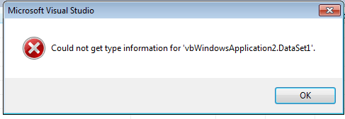

Another error we came across was the inability to download Citrix Receiver and run a Citrix ICA Client file. It appears that Citrix is installed on the Fat Clients in the main building of The Littlehampton Academy, however we constantly receive a 1030 error. We also received a Server Error during this part of the investigation.

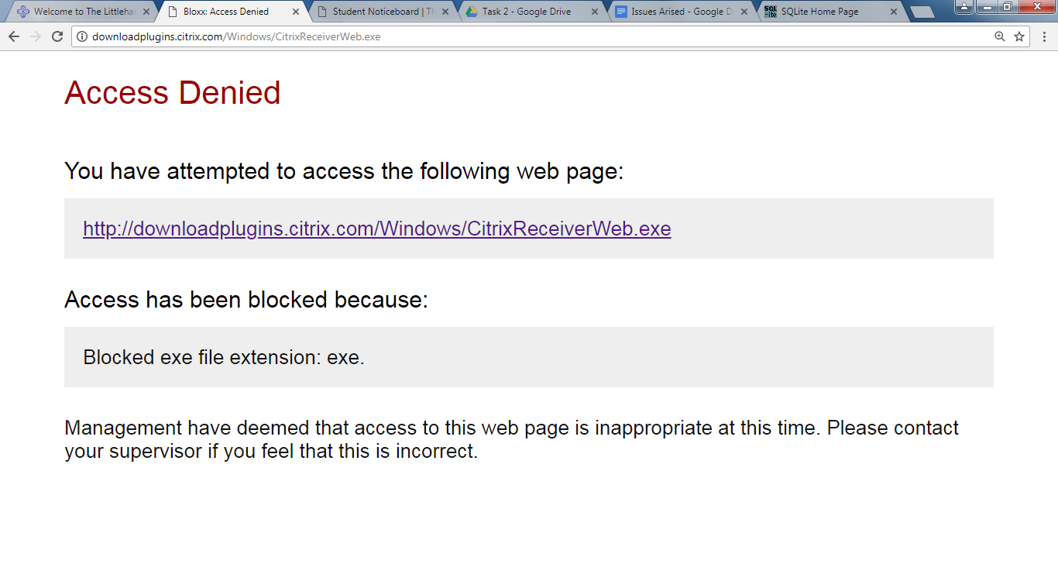

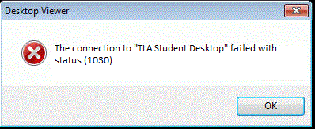

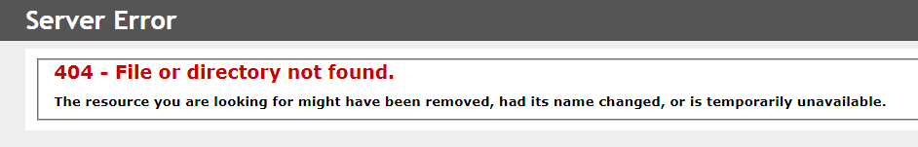

When trying to transfer the visual basic project to The Littlehampton Academy, we kept receiving an error that states that we don’t have permission to move these folders. This has a knock on effect as the ‘Debug’ folder that is being transferred is denied which holds our Visual Basic Executables which then causes design errors for our project.

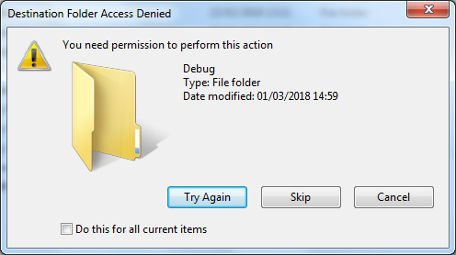

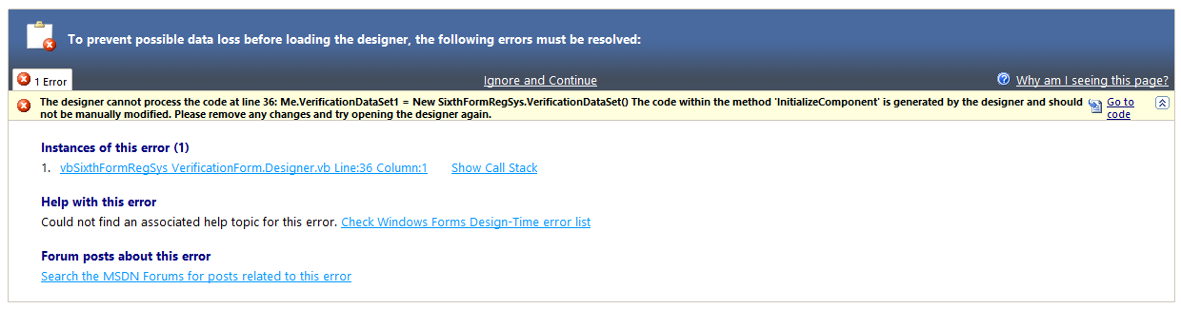

We finally transferred the Visual Basic project to a laptop with higher permission and everything ranging from all the forms to all the datasets were also transferred which suggest that the denied access issue was caused by a lack of access on our side.

The client asked that students would be able to sign in and out multiple times which caused an issue to begin as this would create records which caused an index error as there were duplicate primary keys. Since changing the primary key to the date and time we have eliminated this issue as it’s extremely unlikely that any student would sign in or out at exactly the same time down to the millisecond.

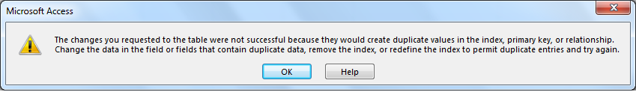

We encountered a few problems when it came to identifying the issues above and identifying potential solutions. We have been in contact with The Littlehampton Academy network services team in order to find solutions for the major issues we’ve come across. Below are two emails that we’ve sent describing the issues and potential solutions we’ve come up with.

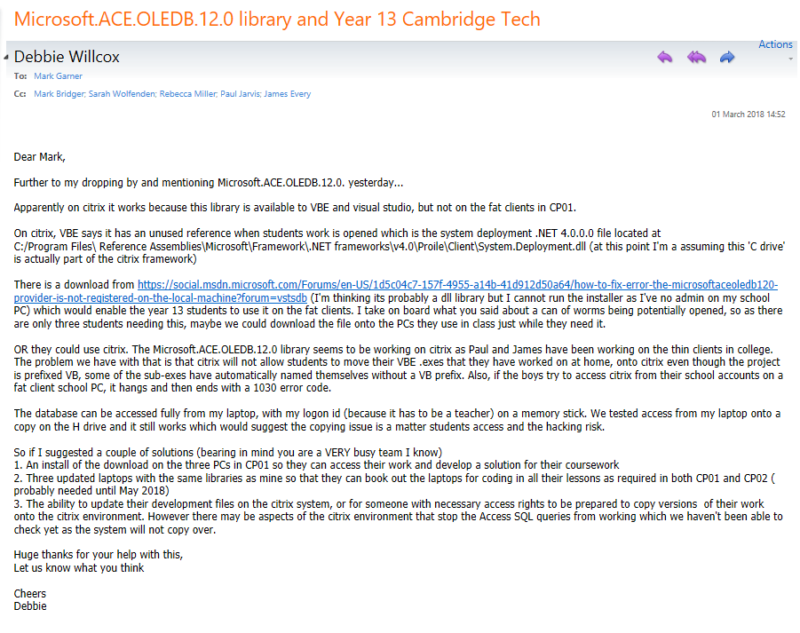

The Littlehampton Academy network services team moved my project from a USB thumb drive over to the H: Drive. This allowed me to bypass any errors with datasets as I had the permission at home to create the datasets and they had the permission to relocate the folders. However when attempting to run my project I always receive a warning but this doesn’t majorly affect this as the project still runs.

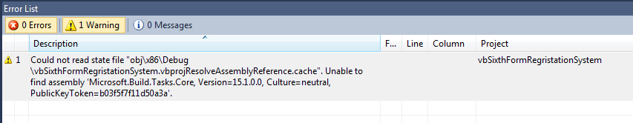

## Third Meeting

### Third Meeting Report

The third meeting with our stakeholder was on the 14th May, at 11:30. I showed him several pictures of our final designs and discussed with him the implementation and maintenance of the system. He signed off saying that he likes the final designs.

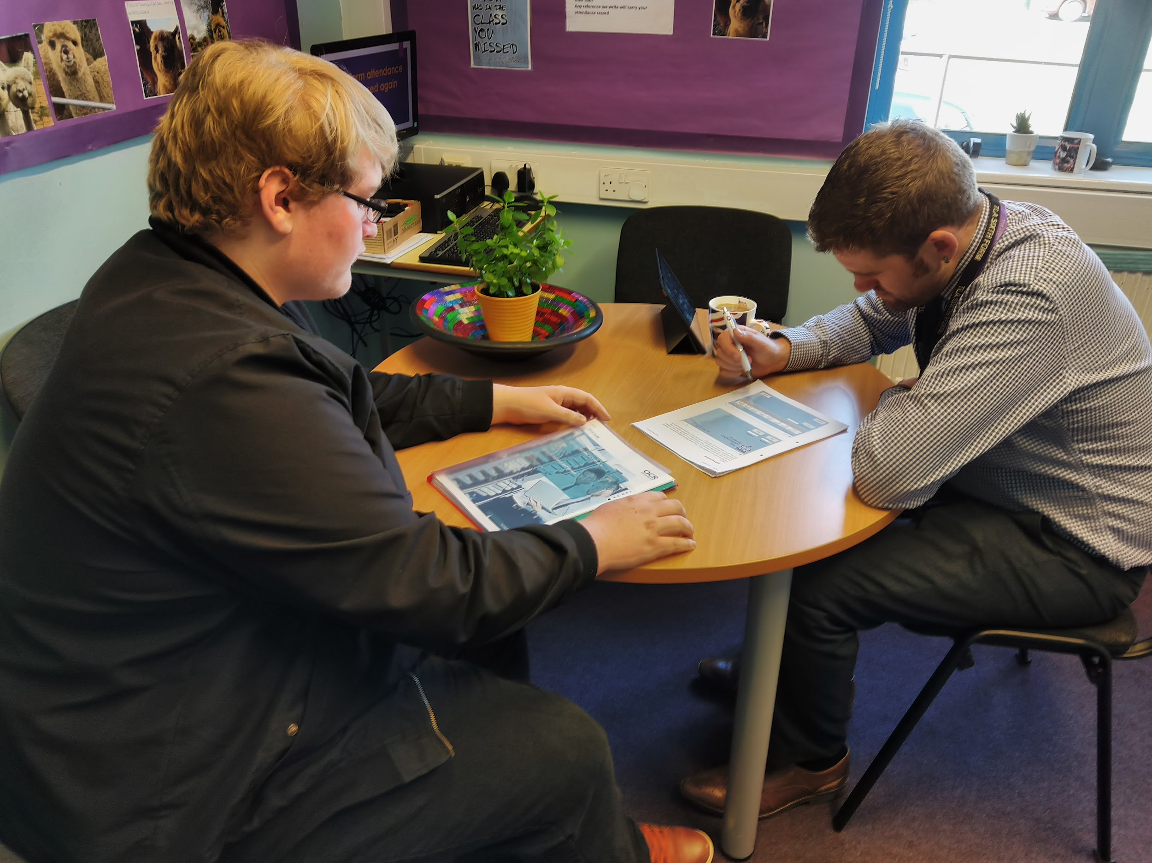

The stakeholder had one suggestion on how we can improve the project. He mentioned that when a member of staff prints out the emergency form data it only shows a date and no time. Since then this has been implemented into the system.

We discussed in great detail on how the system will be maintained and we compiled a set of standard operating procedures. This is step-by-step instructions with the aim to help The Littlehampton Academy IT technicians perform the complex routine maintenance. This set of SOP aims to perform the maintenance efficiently and attempt to reduce miscommunication.



We evaluated our designs and decided that all the decisions we made ranging from the colour style to the way forms look and the features they include all match the stakeholder requirements.

The client’s involvement was a huge help to the success of this project. His advice and ideas helped us in building the perfect system that exceeds the client's hopes and fulfill all of his requirements.

## Video Log

### Video 1: Validation Methods

This video shows the two first validation methods that the user encounters. The two validation methods check whether the user has entered a username or password. If either text box is left empty then the user will receive a message box telling them that no username or password has been detected. This video shows working proof of our first two validation methods.

### Video 2: Incorrect Login

This video shows the user entering a username and password but one of them isn’t correct or there is no record within the database. If the user was to enter either one wrong then a message box will appear telling them that their username or password was not found. This video shows working proof of our third validation method.

### Video 3: Student Login

This video shows the user entering both their username and password correctly and being redirected to the student form. This suggests that the user is a student and their details are within the students table in the database. They’re able to see their timetable on a datagrid when they’re redirected. This video shows working proof that the login system that we developed works with users whose details are written in the database.

### Video 4: Student Logout

This video shows a student entering their details correctly and being redirected to the students form. It also shows that students are logging out. This video shows working proof that students are able to login as well as logout.

### Video 5: Students Sign In

This video shows a student logging in with correct details and being redirected to the student form. They are also attempting to sign in which students will be redirected to another form where it will ask for their student id, first name, last name and SixthForm class. When they enter all these details and click the “Sign In” button then a message box will appear telling them that their sign in was successful. This video shows that this feature which was specifically asked for by our stakeholders is working.

### Video 6: Students Sign Out

This video shows a student logging in with their correct details and being redirected to the student form. It also shows them attempting to signout where they will be redirected to another form which will ask them the same details as signing in as well as asking an extra piece of information which is the reason they’re signing out. This video shows a student who is signing out successfully.

### Video 7: Teacher Login

This video shows a member of staff logging in. The member of staff is then redirected to the staff form where a list of all the students will show in a datagrid. They’re able to filter through the list of students by their first name and can also access the emergency form. This video shows that members of staff can also log in.

### Video 8: Student Filter

This video shows a member of staff logging in and being redirected to the staff form. They’re also filtering through the students by their first name to search for a specific student. This video shows that teachers are able to search through students which is something our stakeholder has asked for.

### Video 9: Emergency Form Before Students Sign in

This video shows a member of staff accessing the emergency form before any students signin. The stakeholder asked for students to appear on this form who has signed in but have not signed out. This video shows that the emergency form works.

### Video 10: Emergency Form After Students Sign in

This video shows a member of staff accessing the emergency form after several students have signed in. They’ve appeared on the form because they’ve signed in but haven't signed out. This video shows proof that students show up on the emergency form when they have signed in.

### Video 11: Emergency Form After Students Signed Out

This video shows a member of staff logging in and accessing the emergency form after one student has signed out. Video 10 shows several students including Paul-David Jarvis whereas in this video his name no longer appears as he has signed out which was a specific feature that our stakeholders requested.

### Video 12: Emergency Form Filters

This video shows a member of staff on the emergency form using filters to sort through students by their first name, last name and SixthForm class. This video shows proof that the filter feature that our stakeholder asked for works.

### Video 13: Emergency Form Print

This video shows a member of staff accessing the emergency form and printing out a list of students who are signed in but not signed out. This was requested to us by our stakeholder and this video shows proof that this feature is working.

## Data Outputs

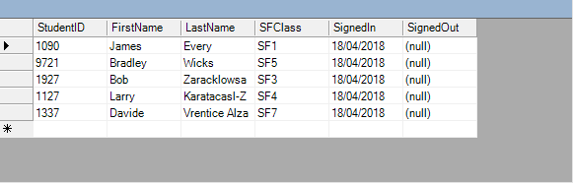

### StudentID

StudentID is an integer and is used to identify individual students. This would normally be a primary key as it is unique, however the stakeholder asked if students can sign in and out multiple times, this would’ve caused an error that states that the changes we requested were not successful because they would create duplicate values.

### FirstName

FirstName is a string. It is used to store the student’s first name. These student details were asked by our stakeholders so we can identify students. It also seems logical to include the student’s first name.

### LastName

LastName is a string. It is used to store the student’s last name. This piece of information is required to help identify the student, it seems logical to have the student’s last name as well as their first name.

### SFClass

SFClass is a string. It is used to store the student’s Sixth Form Class. This piece of information is used to filter students by their Sixth Form in the emergency form. This was a requirement asked by our stakeholder to help them quickly and efficiently to identify and determine if all students are outside and safe.

### SignedIn

SignedIn is a date. It is used to store when the students signin. This was a requirement asked by our stakeholders staff members who access the emergency form can check whether or not a student is still in the building.

### SignedOut

SignedOut would be data. It was requested that this emergency form will only show students who have signed in and haven’t signed out. That is why it will show (null) as we are retrieving data that is empty.

## Smartphone Layout

### Smartphone

The Stakeholder stated that it would be nice for students to be able to register in and out on their smartphones. Below is a picture that shows what the app would look like on an iPhone. This could be implemented several ways such as creating an app and uploading it to the app store which we could have a private url that students can connect to. Another way is that students could use the browsers to connect to Citrix and then use the application that way.

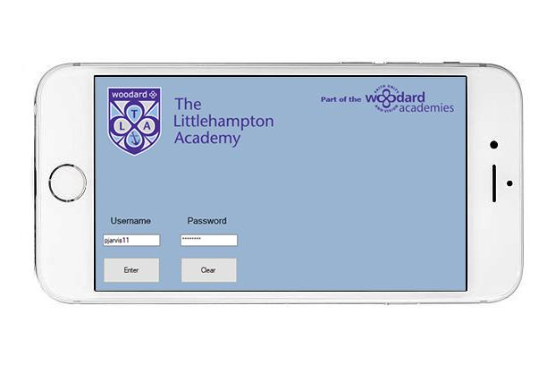

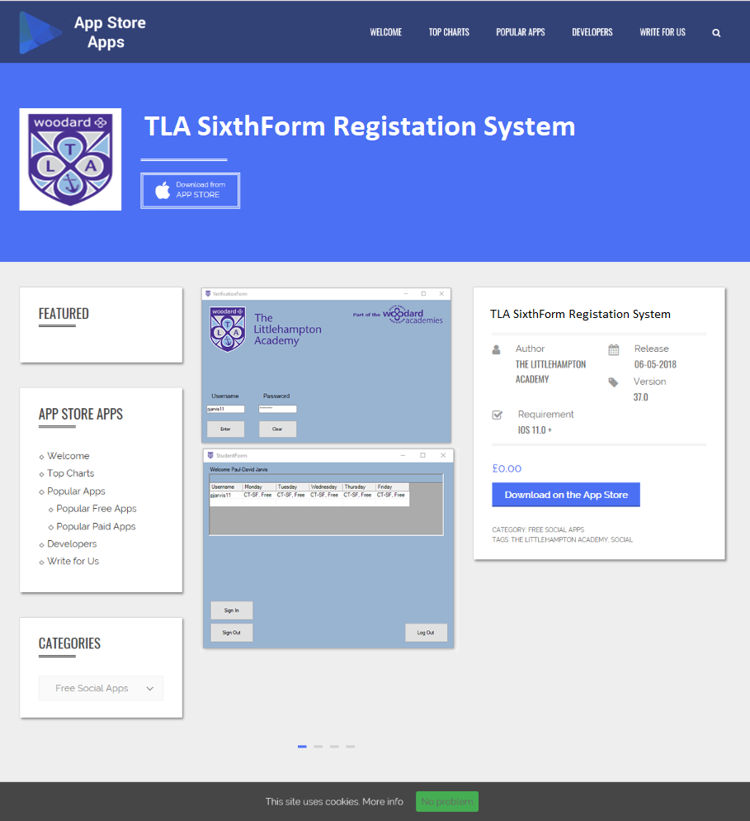

### Legal Issues

There are a few legal issues that we would encounter when creating an app. The main legal issues that we face are Entity Formation, Confidentiality and a few more.

### Entity Formation

It’s always a good idea to limit the personal liability by incorporating an LLC. There are several problems that we could encounter in the long run which could result in a lawsuit so if an LLC was established then personal assets such as houses and cars are safe whereas only the business assets could be in risk.

### Confidentiality

Confidentiality is a major issue in the 21st century as tech is advancing and so is the malicious side of the internet which results in people regularly being reluctant to give their confident information.

This could be problematic as The Littlehampton Academy SixthForm Registration System will have student details which could cause a few issues regarding the Data Protection Act if these details were lost or stolen.

## Testing Table

| The Test | The Expected Outcome | The Actual Outcome |
| --- | --- | --- |
| Type in the wrong username or password.  Non-Functional Requirement | The validation will work and the user will not be able to gain access, a message box will appear telling the user that it is an incorrect password or username. | The actual outcome was the expected outcome. |
| Type in the correct username and password.  Non-Functional Requirement | The user will be able to proceed to their form. | The actual outcome was the expected outcome. |
| Leave username blank.  Non-Functional Requirement | The validation will catch that nothing has been entered into the username textbox. A message box will appear telling the user this. | The actual outcome was the expected outcome. |
| Leave password blank.  Non-Functional Requirement | The validation will catch that nothing has been entered into the password textbox. A message box will appear telling the user this. | The actual outcome was the expected outcome. |
| Entering student details.  Functional Requirement | The user is moved to the students form. | The actual outcome was the expected outcome. |
| Entering staff details.  Functional Requirement | The user will be moved to the staff form. | The user will be moved to the staff form. |
| The student’s timetable shows on the datagrid when they’re redirected to the student form.  Functional Requirement | The datagrid will be filtered based on the username that the user entered when logging in. | The actual outcome was the expected outcome. |
| Sign In.  Functional Requirement | The user will input all the needed data and will receive a message box stating he signed in. | The actual outcome was the expected outcome. |
| Sign Out.  Functional Requirement | The user will repeat the process, however the message box that greets him will say that he signed out. | The actual outcome was the expected outcome. |
| Leave Student ID blank on the sign in and sign out forms.  Non-Functional Requirement | A messagebox will appear telling the user that they’ve left that textbox empty. | The actual outcome was the expected outcome. |
| Leave First Name blank on the sign in and sign out forms.  Non-Functional Requirement | A messagebox will appear telling the user that they’ve left that textbox empty | The actual outcome was the expected outcome. |
| Leave Last Name blank on the sign in and sign out forms.  Non-Functional Requirement | A messagebox will appear telling the user that they’ve left that textbox empty | The actual outcome was the expected outcome. |
| Leave SFClass blank on the sign in and sign out forms.  Non-Functional Requirement | A messagebox will appear telling the user that they’ve left that textbox empty | The actual outcome was the expected outcome. |
| Leave Reason blank on the sign out forms.  Non-Functional Requirement | A messagebox will appear telling the user that they’ve left that textbox empty | The actual outcome was the expected outcome. |
| All the students who have signed in but not out displayed on the emergency menu.  Functional Requirement | The datagrid will show all the students who’ve signed in and not out. | The actual outcome was the expected outcome. |
| Sort the emergency results by the student’s first name.  Functional Requirement | The results will be sorted alphabetically by the student’s first name. | The actual outcome was the expected outcome. |
| Sort the emergency results by student’s last name.  Functional Requirement | The results will be sorted alphabetically by the student’s last name. | The actual outcome was the expected outcome. |
| Sort the emergency results by the student’s SixthForm class.  Functional Requirement | The results will be sorted by the class number. | The actual outcome was the expected outcome. |
| Print the emergency results.  Functional Requirement | The results will be printed off. | The actual outcome was the expected outcome. |

## Testing Log

### Typing in the wrong username or password

If the user was to type in the wrong username or password then the validation in place will stop the user from proceeding and they a message box will pop up on their screens telling them that their username and password was not found, this means that they have either entered the wrong username or the wrong password and it doesn’t match the access database. The image below is the messagebox that will appear if the user was to enter the wrong username or password. The results was what we expected to happen

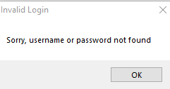

### Typing in the correct username and password

If the correct username and password was entered then the user will be navigated to their designated form. This would be either the students form or the teachers form depending on whether the user is a teacher or student. The screenshots below are of both forms which the user would be navigated to one of them. The results were what we expected to happen.

### Leave username blank

If the user was to leave the username blank then the validation method would stop the user from proceeding and outputs a message box telling the user that no username was detected and to please enter their username. The screenshot below shows what that messagebox looks like.

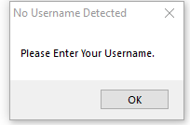

### Leave password blank

If the user were to leave the password blank then they will encounter another validation method and would be stopped from proceeding as well as receiving a messagebox telling the user that no password was detected and to please enter their password. The screenshot below shows what that messagebox looks like.



### Entering students details

If the user was a student and to enter their details then a verification method would check if they are in the students table. If they have entered their username and password correctly and their details are in the students table then they will be navigated to the students form. The screenshot below shows what a student should see when they enter their details and are transferred. An improvement is having the rows long enough so you can see the full timetable.

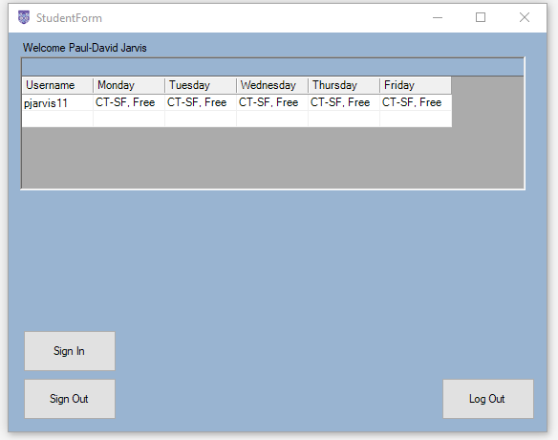

### Entering staff details

If the user was a member of staff and to enter their details then the same verification method would check if they are in the staff table. If they have entered their username and password correctly and their details are in the staff table then they will be navigated to the staff form. The screenshot below shows what the staff member should see when they enter their details and are transferred.

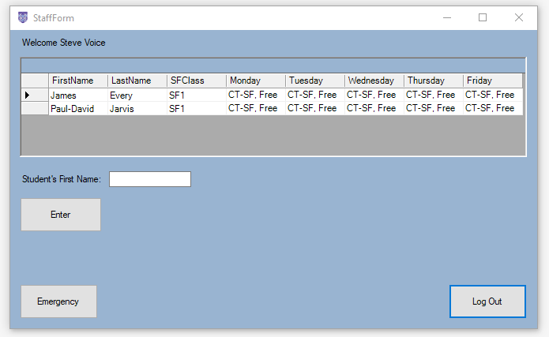

### Students timetables show on the students form

If the user is a student and has entered their details correctly and if they’re in the students table then when they’re transferred to the students form, their timetable should be displayed. The datatable should filter through the timetables table and only display the specific timetable for the username that was entered during the login scene. The screenshot below shows my own timetable. As previously stated in the student details test, an improvement would be if the rows were long enough to show the entire subject.



### Student Sign In

The students can sign in by inputting their Student id, first name, last name and sixthform class. A message box will appear telling them that they have signed in and all the data will be stored in a database. The screenshot below shows me signing in and a message box appearing. An improvement we could make is that all these details are automatically saved instead of having to input manually.

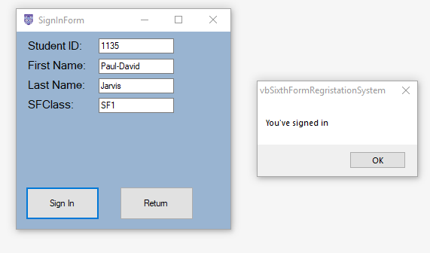

### Student Sign Out

The student can also sign out by entering the same information as well as their reason for signing out. A message box will appear telling the user that he has signed out. This data will also be saved in a database which will be used for the mergency menu. The screenshot below shows me signing out and a message box appearing. An improvement that we could make is to remove the need for having to enter these details except for the reason why you’re signing out.

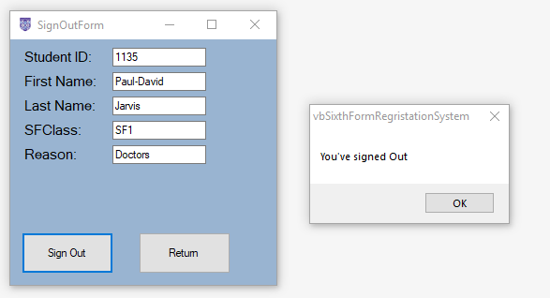

## Testing Plan

### Internal Stakeholder testing

Mr. Voice will test all the functional requirements relating to staff members. The list below will show what he will be testing and the table shows what happened when he tested and what was the expected result.

* Logging in with his details.
* Searching for a student.
* Accessing the emergency form.
* Filter list of students by their first name, last name and SixthForm class.
* Printing out the results.

| Mr. Voice entered his username and password and he was redirected to the staff form. | When Mr. Voice enters his username and password, he will be redirected to the staff form. |
| --- | --- |
| The list of students changed based on what Mr. Voice entered. | The list of students will change based on what the user has entered. E.g. Paul-David’s will be the only one on the list if the user inputs ‘Paul-David’. |
| Mr. Voice clicked on the emergency form button and was redirected. | When Mr. Voice clicks on the emergency form button then he will be redirected to the emergency form. |
| When Mr. Voice selected one of the options on the list box the list of students changed. | When Mr. Voice selects one of the three options on the list box then the emergency form list will change based on what he selects. |
| The list of results was printed when Mr. Voice selected the print button. | When Mr. Voice presses the print button then the emergency list will be printed. |

### External Stakeholder testing

Several students who have a direct interest in this program will be contributing by testing some of the student functional features. The list below will show what they will be testing and the table will show what happens and the expected result.

* Logging in with their username and password.
* Viewing their timetable.
* Singing in.
* Singing out.

| The student was redirected to the student form after they entered their username and password. | The student if entered the correct username and password will be redirected to the student form. |
| --- | --- |
| The student was able to look at their timetable for the entire week. | When the student logs in, they will be redirected to the student form which will include their timetable on it. |
| The student entered all the information and clicked the sign in button. A message box appears telling them that they’ve signed in. | If the user signs in with all relevant information a message box will appear telling them that they’ve signed in. |
| The student entered all the information and clicked the sign out button. A message box appears telling them that they’ve signed out. | If the user signs out with all relevant information a message box will appear telling them that they’ve signed out. |

## Instructions

### Staff Instructions

#### Logging In

The first form will be a verification form. This is where the user enters their details. The user will enter their username in the username textbox which is usually their first name initial and their last name. For Example ‘svoice’. They will then have to enter their password in the password textbox. For Example ‘password’. If the user has entered their details correctly then they will be redirected to the staff form.

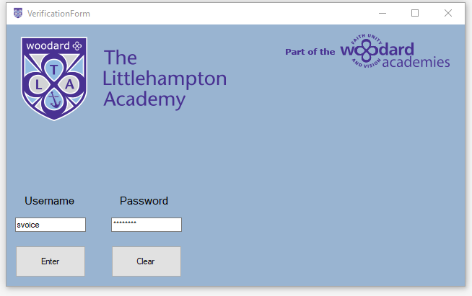



#### Search For A Student

The staff will be able to search for a specific student by entering their first name into the text box and press the enter button. This was asked by the stakeholder so they can locate students quickly. The datagrid which can be seen below will change once the user enters the student’s first name.

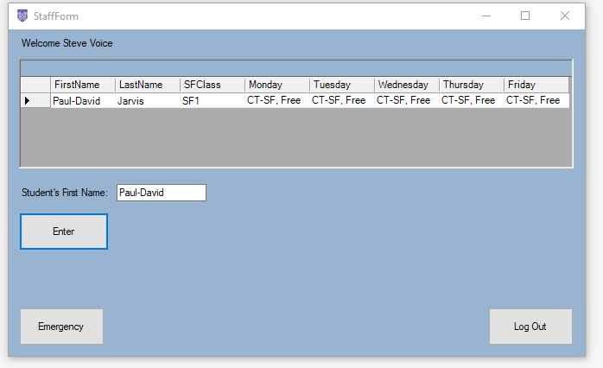

#### Access The Emergency Form

The staff member will be able to the emergency menu which shows a list of students who have signed in and have not signed out. They will also have the option to sort the data alphabetically by the student’s first name or last name as well as sorting the SixthForm classes. The form also includes a question mark button that was intended to help the user understand the list of students.

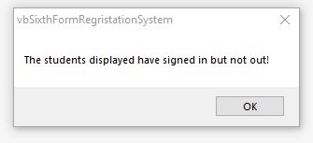

This is a screenshot of the emergency form with a student who is still signed in. The column that stores the date and time is only showing the date however the application will show the staff member the date and time that they signed in which is seen below.

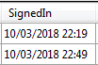

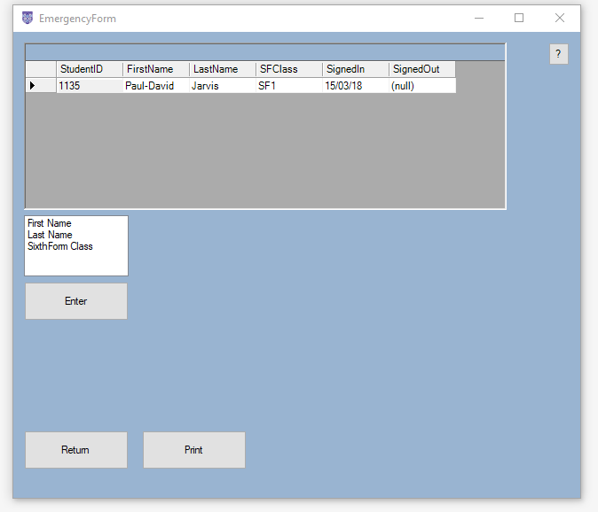

This is a screenshot of the emergency form with all the SixthForm students who have signed in and out. The datagrid will show no students as the SQL query we ran will only retrieve students who have signed in and not out.

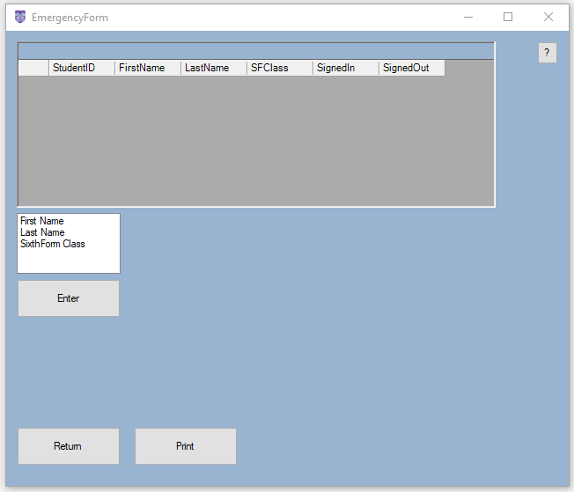

#### Printing Out

The staff member will also have the option to print the students list out. This is a requirement that our stakeholder has asked for. Below is a picture of what the print out will look like.

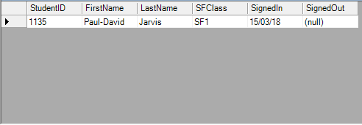

### Student Instructions

#### Log In

Same as the staff instructions, the student will also have to enter their username and password in order to proceed to the next form. The student should enter their username in the username textbox which is usually their first name initial, their full last name and the year that the student joined The Littlehampton Academy. Once the student has entered their correct details then they will be redirected to the student form.

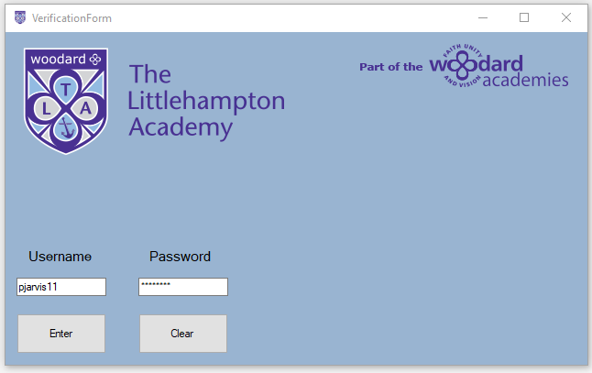

The student form will include a datagrid which will show the user their timetable. The SQL query filters based on the username that the user inputted earlier so this must be correct. They will also have the option to sign in and out as well as logging out which will redirect them to the verification form.



#### Signing In

The student will have to enter several details about themself in order to sign in. This is so the data can be stored correctly as well as be retrieved efficiently and quickly. They will have to enter their Student ID, First Name, Last Name and their SixthForm Class. They will then receive a message that tells them they have signed in.



#### Signing Out

The student will also be able to sign out. They will have to enter one piece of additional information as well as everything else. They will have to enter their Student ID, First Name, Last Name, SixthForm Class and the Reason they are signing out.



## Implementation Log

### 07/02/2018

1. The new visual basic application was started.
2. Two databases were made. One for users which is used to store the usernames and passwords of the students. The second database holds the timetables for the students which can be read into the application.

### 08/2/2018

1. A login system was made with direct access to the ‘users’ database which allows people to add authorised users using their username (pjarvis11) and password (password). This functional requirement has verification which either grants or denies access depending on whether their username and password are in the database. This also satisfies the non functional requirement of security and keeping the data safe.
2. The timetable database was updated with two students.
3. Functionality was added which is used to read the students timetable and display their lessons for the entire week onto the form.

### 09/02/2018

1. The code had some database bugs which mostly were fixed. The program receives an error when we try to read the timetable data as the timetable can not be located.

### 10/02/2018

1. I designed an entirely new database with several tables that will hold all the data I need to import.
2. I designed a new login system that will detect whether the username inputted was either a student username or a teacher username and then the teacher or student will be moved to different forms depending on their access. The login system now has two verification methods. For example if the username and password are entered and are not in the database then the user will receive an error. The second verification method is that the detailed entered use a SQL statement to cross analyse both the students and teachers database to see the level of access and if it is a student or admin.
3. I have planned out all the forms and all the functions that are being added. For example, form 4 is the emergency interface which allows the teacher to receive all the students data and can distinguish those who are safe and those who could still be in the building.
4. Form 2 otherwise known as the student interface has the functionality of being able to sign in or out and display your timetable.
5. I updated the database with my details and 50 random students to showcase the usability of the system.
6. I have linked a dataset with the grid view and it is now showing everyone's timetable. You can now search for the database using your student id. It will show you your filtered results as your student id, your weekly timetable and your first and last name.
7. I have now added new functionality to the teachers interface. As soon as a teacher enters their details they’re redirected to another form which shows all the students and you can now filter results based on class.

### 11/02/2018

1. I have used a data adapter, a data connection, a dataset and a binding source to show filtered results by using a SQL statement that shows all the students, the date they got in and shows either “(null)” if they’re still in and a out date that shows if they’ve signed out.
2. I’ve added two new forms for signing in and out. I did this as it would be easier to sort out the datasets and binding sources.
3. The forms have now been planned with several text boxes, labels and two buttons. The login and logout interface will now ask you for your first name, last name, class, reason, student id and the date. This data will now be automatically exported to database tables “signin” and “signout”.
4. For an unknown reason I have lost all my datasets and binding sources. I am unable to add any new data source as I always receive an error when trying to create the new data source: “Could not get type information for ‘vbTLASixthForm.SixthFormDBDataSet’.

### 13/02/2018

1. I recreated the forms at home using my own version of Visual basic. I linked the application up with a database on my desktop and I never received any errors regarding so I can only assume that something in the school settings was preventing my datasets.

### 14/02/2018

1. I added a function on the teachers interface that allows the teachers to search students timetables based on the student ID.
2. I have now added two separate forms with a variety of functions that allow admins to update students and teachers details, add new students and teachers to the database, delete students and teachers details.
3. I have also added navigation functions that allow admins to go to the first record in the database, the previous and next record in the database and the last record in the database.

### 16/02/2018

1. I deleted the dataset that retrieved the data from the “SignIn” table in the database and replaced it with a coded database straight from the dataset created when we linked the database to visual basic. The data inputted in the sign in form is now stored in the database and can be retrieved from the emergency menu.
2. I’ve created a new dataset with a query that will retrieve the data from three tables (“Students”, “SignIn” and “SignOut”) when a teacher accesses the emergency menu they will retrieve data for the students along with whether they’ve signed in or signed out.
3. The data will only show up in the emergency menu if they’ve signed in and out. This can cause problems.
4. I’ve added three new data grids on the admin form that shows the admin user all the data for the students, teachers and the students timetables.

### 26/02/2018

1. Fixed my private subroutine that is used to navigate the student records.

### 27/02/2018

1. Fixed my private subroutine that is used to navigate the teacher records.

### 01/03/2018

1. I’ve added a Class Form that will be used by teachers to select their classes and courses and allow them to use combo boxes to mark their presence.
2. I’ve also added a second form for the Pastoral Staff. They will be able to retrieve the timetable data, as well as be able to add new records, update existing records and delete old records. I also included a subroutine on this form that will be used to navigate the students timetable records and a datagrid showing the courses.
3. I have updated the admin form with a button that redirects the user to another form which they can add, edit or delete pastoral staff records.

### 05/03/2018

1. Added a new form that will be used to record whether or not the student is in. The use of boolean boxes make it easy for the teachers to mark students present or not.

### 06/03/2018

1. Added a button and subroutine to print out the list of students that are displayed in the datagrid for the emergency menu.

### 09/03/2018

1. After a meeting with our stakeholders we decided that their systems for student management was sufficient enough to keep so we scrapped a few forms and focused solely on a system used for signing in and out that provides an emergency menu and timetables. I went through the database and deleted some tables that were not needed. In addition to this I deleted some form that we decided that we don’t need and added an extra line of code that now filters the timetable on the student form based on what the user inputs when they log in.

### 10/03/2018

1. Everytime I signed in or out and the data was saved to the database the date was always wrong. The date usually goes back 3 decades but since I’ve defined the variable that stores the date and time as the local system's date and time (now) the date and time has been corrected. The emergency menu datagrid would display the students who’ve signed in and out. This causes a major issue as the query it runs only retrieves the students who have signed in and out so they won’t retrieve students who have only signed in. This is exactly the opposite of what our clients wanted, however refining the SQL statement and instead of using an INNER JOIN option I used an OUTER JOIN option then filtered the SQL query to only retrieve students who signed out columns in the database are empty or null.
2. Added a help button on the form that tells the user that the students displayed on the datagrid are students who have signed in and have not signed out.

### 12/03/2018

1. The stakeholder wanted the requirement that students could sign out and multiple times which caused an index error as they were duplicate primary keys. I’ve now changed the primary key to the time and date from the username which solved the issue.

### 14/03/2018

1. Added a listbox to the emergency form which gives the option to sort by First Name, Last Name or SixthForm Class. In addition to this I’ve added a datagrid and dataset that will show the user the full list of students with their timetables as this is what the stakeholder wanted.

## Codes & Annotations

### Verification Form



Imports System.Data.OleDb

Public Class VerificationForm

Dim provider As String

Dim dataFile As String

Dim connString As String

Dim myConnection As OleDbConnection = New OleDbConnection

Private Sub BtnEnter_Click(ByVal sender As System.Object, ByVal e As System.EventArgs) Handles BtnEnter.Click

provider = "Provider=Microsoft.ACE.OLEDB.12.0;Data Source=" 'Database provider'

dataFile = "H:\ICT\Willcox\IT Guru Project\vbSixthFormRegristationSystem\vbSixthFormRegristationSystem\TLADataBase.accdb" 'DB location'

connString = provider & dataFile

myConnection.ConnectionString = connString

myConnection.Open() 'opens a connection with the database'

Dim student As OleDbCommand = New OleDbCommand("SELECT * FROM [tblStudents] WHERE [Username] = '" & TextBoxUsername.Text & "' AND [PassW] = '" & TextBoxPassW.Text & "'", myConnection)

Dim stu As OleDbDataReader = student.ExecuteReader 'Defines a student who has their username & password in the student table'

Dim staff As OleDbCommand = New OleDbCommand("SELECT * FROM [tblStaff] WHERE [Username] = '" & TextBoxUsername.Text & "' AND [PassW] = '" & TextBoxPassW.Text & "'", myConnection)

Dim sta As OleDbDataReader = staff.ExecuteReader 'Defines a staff member who has their username & password in the staff table'

Dim StuFound As Boolean = False

Dim StaFound As Boolean = False

Dim FirstName As String = "" 'Defines firstname as whatever is entered'

Dim LastName As String = "" 'Defines lastname as whatever is entered'

While stu.Read

StuFound = True

FirstName = stu("FirstName").ToString

LastName = stu("LastName").ToString

End While

While sta.Read

StaFound = True

FirstName = sta("FirstName").ToString

LastName = sta("LastName").ToString

End While

If TextBoxUsername.Text = String.Empty Then 'Checks whether a username has not been entered'

MessageBox.Show("Please Enter Your Username.", "No Username Detected") 'Validation Method'

ElseIf TextBoxPassW.Text = String.Empty Then 'Checks whether a password has not been entered'

MessageBox.Show("Please Enter Your Password.", "No Password Detected") 'Validation Method'

ElseIf StuFound = True Then

Me.Hide() 'Hides verification form'

StudentForm.Show() 'shows student form'

StudentForm.LabelWelcome.Text = "Welcome " & FirstName & " " & LastName 'changes the label to welcome and their first and last name'

StudentForm.TblTimeTableBindingSource.Filter = "Username = '" & Me.TextBoxUsername.Text & " ' " 'filters timetable for specific user'

ElseIf StaFound = True Then

Me.Hide() 'Hides verification form'

StaffForm.Show() 'shows staff form'

StaffForm.LabelWelcome.Text = "Welcome " & FirstName & " " & LastName 'changes label to welcome and their name'

Else : MsgBox("Sorry, Username Or Password Not Found.", MsgBoxStyle.OkOnly, "Invalid Login") 'if none above is true then shows this error' 'Validation Method'

End If

myConnection.Close() 'closes database connection'

End Sub

Private Sub BtnClear_Click(ByVal sender As System.Object, ByVal e As System.EventArgs) Handles BtnClear.Click

TextBoxUsername.Text = "" 'clears username textbox'

TextBoxPassW.Text = "" 'clear password textbox'

TextBoxUsername.Focus()

End Sub

End Class

### Student Form



Public Class StudentForm

Private Sub BtnSignIn_Click(ByVal sender As System.Object, ByVal e As System.EventArgs) Handles BtnSignIn.Click

SignInForm.Show() 'Shows the Sign In form'

SignInForm.StudentIDTextBox.Clear() 'Clears StudentID textbox on that form'

SignInForm.FirstNameTextBox.Clear() 'Clears FirstName textbox on that form'

SignInForm.LastNameTextBox.Clear() 'Clears LastName textbox on that form'

SignInForm.SFClassTextBox.Clear() 'Clears SFClass textbox on that form'

Me.Hide() 'Hides Student Form'

End Sub

Private Sub BtnSignOut_Click(ByVal sender As System.Object, ByVal e As System.EventArgs) Handles BtnSignOut.Click

SignOutForm.Show() 'Shows the Sign Out form'

SignOutForm.StudentIDTextBox.Clear() 'Clears StudentID textbox on that form'

SignOutForm.FirstNameTextBox.Clear() 'Clears FirstName textbox on that form'

SignOutForm.LastNameTextBox.Clear() 'Clears LastName textbox on that form'

SignOutForm.SFClassTextBox.Clear() 'Clears SFClass textbox on that form'

SignOutForm.ReasonTextBox.Clear() 'Clears Reason textbox on that form'

Me.Hide() 'Hides Student Form'

End Sub

Private Sub BtnLogout_Click(ByVal sender As System.Object, ByVal e As System.EventArgs) Handles BtnLogout.Click

VerificationForm.Show() 'Shows verification form'

VerificationForm.TextBoxUsername.Clear() 'Clears Username textbox on that form'

VerificationForm.TextBoxPassW.Clear() 'Clears Password textbox on that form'

Me.Close() 'Closes Student Form'

End Sub

Private Sub StudentForm_Load(ByVal sender As System.Object, ByVal e As System.EventArgs) Handles MyBase.Load

Me.TblTimeTableTableAdapter.Fill(Me.TLADataBaseDataSet.tblTimeTable) 'Loads timetables into Data Grid'

End Sub

End Class

### Sign In Form



Public Class SignInForm

Dim MaxRows As Integer 'defines the variable "MaxRows" as an integer'

Dim incdec As Integer 'defines the variable "incdec" as an integer'

Dim con As New OleDb.OleDbConnection 'defines the variable "con" as a OleDataBaseConnection'

Dim provider As String 'defines the variable "provider" as string, "ACE.12.0.0"'

Dim datafile As String ''defines the variable "datafile" as string, location of DB'

Dim ds As New DataSet 'defines the variable "ds" as a new dataset'

Dim da As OleDb.OleDbDataAdapter 'defines the variable "da" as a OleDataBaseDataAdapter'

Dim sql As String 'defines the variable "sql" as string'

Dim DateAndTime As Date 'Defines the variable "DataAndTime" as date'

Private Sub SignInForm_Load(ByVal sender As System.Object, ByVal e As System.EventArgs) Handles MyBase.Load

Me.TblSignInTableAdapter.Fill(Me.TLADataBaseDataSet.tblSignIn)

provider = "Provider=Microsoft.ACE.OLEDB.12.0;Data Source=" 'sets DB provider'

datafile = "H:\ICT\Willcox\IT Guru Project\vbSixthFormRegristationSystem\vbSixthFormRegristationSystem\TLADataBase.accdb" 'sets DB location'

DateAndTime = TimeOfDay 'sets "DateAndTime" as TimeOfDay'

con.ConnectionString = provider & datafile

con.Open() 'Opens a DB connection'

sql = "SELECT * FROM tblSignIn" 'selects all data from the signin table'

da = New OleDb.OleDbDataAdapter(sql, con)

da.Fill(ds, "SignInRecords") 'fills DataAdapter with new dataset'

con.Close() 'Closes DB connection'

MaxRows = ds.Tables("SignInRecords").Rows.Count 'sets "MaxRows" as the total of rows in table'

incdec = -1 'Sets "incdec" as -1'

DateAndTime = Now 'sets "DataAndTime" as local time'

End Sub

Private Sub BtnSignIn_Click(ByVal sender As System.Object, ByVal e As System.EventArgs) Handles BtnSignIn.Click

If incdec <> -1 Then 'Checks whether incdec is not equal to -1'

incdec = 0 'resets incdec to 0'

End If

Dim cb As New OleDb.OleDbCommandBuilder(da)

Dim DsNewRow As DataRow 'defines a new row as a datarow'

If StudentIDTextBox.Text = String.Empty Then

MessageBox.Show("Please Enter Your Student ID.", "No Student ID Detected.") 'Checks if StudentID textbox is empty' 'Validation Method'

ElseIf FirstNameTextBox.Text = String.Empty Then

MessageBox.Show("Please Enter Your First Name.", "No First Name Detected.") 'Checks if FirstName textbox is empty' 'Validation Method'

ElseIf LastNameTextBox.Text = String.Empty Then

MessageBox.Show("Please Enter Your Last Name.", "No LastName Detected.") 'Checks if LastName textbox is empty' 'Validation Method'

ElseIf SFClassTextBox.Text = String.Empty Then

MessageBox.Show("Please Enter Your SixthForm Class.", "No SixthForm Class Detected.") 'Checks if SFClass textbox is empty' 'Validation Method'

Else

DsNewRow = ds.Tables("SignInRecords").NewRow() 'defines a the new row variable as a new row in Sign In dataset'

DsNewRow.Item(0) = StudentIDTextBox.Text 'Adds the first new row as whatever was entered in the StudentID textbox'

DsNewRow.Item(1) = FirstNameTextBox.Text 'Adds the second new row as whatever was entered in the FirstName textbox'

DsNewRow.Item(2) = LastNameTextBox.Text 'Adds the third new row as whatever was entered in the LastName textbox'

DsNewRow.Item(3) = SFClassTextBox.Text 'Adds the fourth new row as whatever was entered in the SFClass textbox'

DsNewRow.Item(4) = DateAndTime.ToString 'Adds the fifth new row as the data and time'

ds.Tables("SignInRecords").Rows.Add(DsNewRow) 'adds new record'

da.Update(ds, "SignInRecords") 'saves new record'

MsgBox("You've signed in", MsgBoxStyle.OkOnly) 'outputs confirmation message'

End If

End Sub

Private Sub BtnReturn_Click(ByVal sender As System.Object, ByVal e As System.EventArgs) Handles BtnReturn.Click

StudentForm.Show() 'Shows Student Form'

StudentForm.LabelWelcome.Hide() 'Hides the label on the Student Form'

Me.Close() 'Closes the Sign In Form'

End Sub

End Class

### Sign Out Form



Public Class SignOutForm

Dim MaxRows As Integer 'defines the variable "MaxRows" as an integer'

Dim incdec As Integer 'defines the variable "incdec" as an integer'

Dim con As New OleDb.OleDbConnection 'defines the variable "con" as a OleDataBaseConnection'

Dim provider As String 'defines the variable "provider" as string, "ACE.12.0.0"'

Dim datafile As String ''defines the variable "datafile" as string, location of DB'

Dim ds As New DataSet 'defines the variable "ds" as a new dataset'

Dim da As OleDb.OleDbDataAdapter 'defines the variable "da" as a OleDataBaseDataAdapter'

Dim sql As String 'defines the variable "sql" as string'

Dim DateAndTime As Date 'Defines the variable "DataAndTime" as date'

Private Sub SignOutForm_Load(ByVal sender As System.Object, ByVal e As System.EventArgs) Handles MyBase.Load

Me.TblSignOutTableAdapter.Fill(Me.TLADataBaseDataSet.tblSignOut)

provider = "Provider=Microsoft.ACE.OLEDB.12.0;Data Source=" 'sets DB provider'

datafile = "H:\ICT\Willcox\IT Guru Project\vbSixthFormRegristationSystem\vbSixthFormRegristationSystem\TLADataBase.accdb" 'sets DB location'

DateAndTime = TimeOfDay 'sets "DateAndTime" as TimeOfDay'

con.ConnectionString = provider & datafile

con.Open() 'Opens a DB connection'

sql = "SELECT * FROM tblSignOut" 'selects all data from the SignOut table'

da = New OleDb.OleDbDataAdapter(sql, con)

da.Fill(ds, "SignOutRecords") 'fills DataAdapter with new dataset'

con.Close() 'Closes DB connection'

MaxRows = ds.Tables("SignOutRecords").Rows.Count 'sets "MaxRows" as the total of rows in table'

incdec = -1 'Sets "incdec" as -1'

DateAndTime = Now 'sets "DataAndTime" as local time'

End Sub

Private Sub BtnSignOut_Click(ByVal sender As System.Object, ByVal e As System.EventArgs) Handles BtnSignOut.Click

If incdec <> -1 Then 'Checks whether incdec is not equal to -1'

incdec = 0 'resets incdec to 0'

End If

Dim cb As New OleDb.OleDbCommandBuilder(da)

Dim DsNewRow As DataRow 'defines a new row as a datarow'

If StudentIDTextBox.Text = String.Empty Then

MessageBox.Show("Please Enter Your Student ID.", "No Student ID Detected.") 'Checks if StudentID textbox is empty' 'Validation Method'

ElseIf FirstNameTextBox.Text = String.Empty Then

MessageBox.Show("Please Enter Your First Name.", "No First Name Detected.") 'Checks if FirstName textbox is empty' 'Validation Method'

ElseIf LastNameTextBox.Text = String.Empty Then

MessageBox.Show("Please Enter Your Last Name.", "No LastName Detected.") 'Checks if LastName textbox is empty' 'Validation Method'

ElseIf SFClassTextBox.Text = String.Empty Then

MessageBox.Show("Please Enter Your SixthForm Class.", "No SixthForm Class Detected.") 'Checks if SFClass textbox is empty' 'Validation Method'

Else

DsNewRow = ds.Tables("SignOutRecords").NewRow() 'defines a the new row variable as a new row in Sign In dataset'

DsNewRow.Item(0) = StudentIDTextBox.Text 'Adds the first new row as whatever was entered in the StudentID textbox'

DsNewRow.Item(1) = FirstNameTextBox.Text 'Adds the second new row as whatever was entered in the FirstName textbox'

DsNewRow.Item(2) = LastNameTextBox.Text 'Adds the third new row as whatever was entered in the LastName textbox'

DsNewRow.Item(3) = SFClassTextBox.Text 'Adds the fourth new row as whatever was entered in the SFClass textbox'

DsNewRow.Item(4) = DateAndTime.ToString 'Adds the fifth new row as the data and time'

ds.Tables("SignOutRecords").Rows.Add(DsNewRow) 'adds new record'

da.Update(ds, "SignOutRecords") 'saves new record'

MsgBox("You've signed Out", MsgBoxStyle.OkOnly) 'outputs confirmation message'

End If

End Sub

Private Sub BtnReturn_Click(ByVal sender As System.Object, ByVal e As System.EventArgs) Handles BtnReturn.Click

StudentForm.Show() 'Shows Student Form'

StudentForm.LabelWelcome.Hide() 'Hides the label on the Student Form'

Me.Close() 'Closes the Sign Out Form'

End Sub

End Class

### Staff Form



Public Class StaffForm

Private Sub BtnEmergency_Click(ByVal sender As System.Object, ByVal e As System.EventArgs) Handles BtnEmergency.Click

EmergencyForm.Show() 'Shows emergency form'

Me.Hide() 'Hides staff form'

End Sub

Private Sub BtnLogOut_Click(ByVal sender As System.Object, ByVal e As System.EventArgs) Handles BtnLogOut.Click

VerificationForm.Show() 'Show verification form'

VerificationForm.TextBoxUsername.Clear() 'Clears Username textbox on that form'

VerificationForm.TextBoxPassW.Clear() 'Clears Password textbox on that form'

Me.Close() 'Closes Staff form'

End Sub

Private Sub BtnEnter_Click(sender As Object, e As EventArgs) Handles BtnEnter.Click

If TextBoxStudentName.Text = String.Empty Then 'Checks whether a first name has been entered' 'Validation Method'

MessageBox.Show("Please Enter The Student's First Name.", "No First Name Detected") 'Shows a message box if the above is true'

Else

Me.TblStudentsBindingSource.Filter = "FirstName = '" & Me.TextBoxStudentName.Text & " ' " 'Filters datagrid on staff form'

End If

End Sub

Private Sub StaffForm_Load(sender As Object, e As EventArgs) Handles MyBase.Load

Me.OleDbDataAdapter1.Fill(Me.StaffFormDataSet1.tblStudents) 'fills DataAdapter with student records'

End Sub

End Class

### Emergency Form



Imports System.Drawing.Printing

Public Class EmergencyForm

Dim Bitmap As Bitmap

Dim DateAndTime As Date 'Defines the variable "DateAndTime" as a date'

Private Sub BtnReturn_Click(ByVal sender As System.Object, ByVal e As System.EventArgs) Handles BtnReturn.Click

StaffForm.Show() 'Show staff form'

Me.Close() 'Emergency form closes'

End Sub

Private Sub BtnFilter_Click(ByVal sender As System.Object, ByVal e As System.EventArgs) Handles BtnFilter.Click

If ListBox1.SelectedIndex = 0 Then

Me.TblSignInBindingSource.Sort = "FirstName" 'Sorts by FirstName'

ElseIf ListBox1.SelectedIndex = 1 Then

Me.TblSignInBindingSource.Sort = "LastName" 'Sorts by LastName'

Else ListBox1.SelectedItem = 3

Me.TblSignInBindingSource.Sort = "SFClass" 'Sorts by SFClass'

End If

End Sub

Private Sub BtnButton_Click(ByVal sender As System.Object, ByVal e As System.EventArgs) Handles BtnButton.Click

MsgBox("The students displayed have signed in but not out!", MsgBoxStyle.OkOnly) 'For the Help Button'

End Sub

Private Sub EmergencyForm_Load(ByVal sender As Object, ByVal e As EventArgs) Handles MyBase.Load

Me.OleDbDataAdapter2.Fill(Me.EmergencyDataSet1.tblSignIn) 'Fills DataAdapter with emergency records'

DateAndTime = Now 'Sets "DateAndTime" as local time'

End Sub

Private Sub BtnPrint_Click(sender As Object, e As EventArgs) Handles BtnPrint.Click

PrintDoc.Print() 'Prints document'

End Sub

Private Sub PrintDoc_PrintPage(ByVal sender As System.Object, ByVal e As System.Drawing.Printing.PrintPageEventArgs) Handles PrintDoc.PrintPage

Dim bm As New Bitmap(Me.DataGrid1.Width, Me.DataGrid1.Height)

DataGrid1.DrawToBitmap(bm, New Rectangle(0, 0, Me.DataGrid1.Width, Me.DataGrid1.Height))

e.Graphics.DrawImage(bm, 0, 0)

End Sub

End Class

## Target Profiles

The system has only two levels of access as we discussed with the stakeholder and we came to the decision that multiple levels for different types of staff wasn’t necessary. The admin staff will be able to add students by adding their names to the database.

### Student Target Profile

Name: James Every

Age: 18

Gender: Male

Education: Sixth Form student

System Level: Student

IT Experience: KS3 ICT

Likely method of access: Smartphone & Computer

Training: A basic introduction will be needed

### Staff Target Profile

Name: Erica Matilda

Age: 26

Gender: Female

Education: Harvard University

System Level: Staff

IT Experience: Little

Likely method of access: Smartphone & Computer

Training: Intensive introduction

## Form Plan Evaluation

We changed a variety of things about our original form plans with stakeholder involvement. The original form plans had some features that we decided to keep as these were what the stakeholder wanted.

Several things that went well with our forms. The stakeholder noted on the first form that the overall colour style with the use of The Littlehampton Academy logos looked professional. The form was simple to use and good feedback was given across the board by all students who used it.



The student form was also noted for its continuous colour use and the ability for students to see their timetable. However, the first plan we showed our stakeholder had all the students timetables, the stakeholder noted that this could be used maliciously and suggested that only the student who logged in timetable would appear. Since this feedback was given, we have implemented this feature and since review the stakeholder favorited the change. This could be improved by increasing the size of the columns so all lessons are clear to see.



The sign in and out form were very familiar except for one difference which was an extra piece of information was required on the sign out form. Again the stakeholder noted that it looked professional and was simple and easy to use for all students.



The staff form was another form that we changed to feature the stakeholders suggestion. We implemented the feature that staff members can search for students and that it shows their timetable and where the staff members can find them. The stakeholder suggested this incase of an emergency and a student needs to be quickly located without any hassle.



Another thing that went well with the emergency form is the ability for the staff member to filter and sort the results to make it easier to check whether a student has arrived at the emergency point. The stakeholder asked for the ability to sort the list of students by their first name, last name and their sixth form class. Also the stakeholder asked for the ability to print the list out. Since that review we have now implemented these features into the system.



We originally had a pastoral staff form and an admin form, however with stakeholder feedback we have sinced removed them and integrated all into a single entity which is staff. This was suggested by the stakeholder as The Littlehampton Academy already has several different systems in place that sort attendance. Etc.

## User Acceptance Test Plan

Please complete the below table by writing a tick or cross in the “Passed?” column if the test is successful and if you have any feedback to give then please write it in the “Suggestions | Improvements | Feedback” column. The decision to deploy this system has been parked due to a change of pastoral system.

If you’re a student then please complete the rows that include “Student” in the “Test No.” column and the same if you’re a member of staff.

| Test No. | Test Details | Passed? | Suggestions | Improvements | Feedback |
| --- | --- | --- | --- |
| 1  Student Staff | Protection.  You must require a password and username to log in to the system. Users will be denied with the wrong username or password. |  |  |
| 2  Student  Staff | TimeTable.  Your timetable will be displayed when you log on. |  |  |
| 3  Student | Signing In.  Users will be able to sign in by clicking the sign in button and entering their student id, first name, last name and tutor. |  |  |
| 4  Student | Signing Out.  Users will be able to sign out by clicking the sign out button and entering their student id, first name, last name, tutor and the reason they’re signing out. |  |  |
| 5  Staff | Student Search.  Staff members should be able to search for a specific student by entering their first name into the textbox. |  |  |
| 6  Staff | Emergency Form.  Staff members should be able to access the emergency form by clicking on the emergency button. |  |  |
| 7  Staff | Filtering Emergency List.  Staff members can also filter the list of students by selecting one of three options on the listbox and clicking the filter button. |  |  |
| 8  Staff | Printing Emergency List.  Staff members can also print out the emergency list by selecting the print button. |  |  |
|  | | | |
|  | The user has tested the system and agrees that all the system requirements above have been tested and wholly works. | Date  ________ | Signature  ___________________ |

# References

https://en.wikipedia.org/wiki/Incremental_build_model

http://www.base36.com/2012/12/agile-waterfall-methodologies-a-side-by-side-comparison/

https://en.wikipedia.org/wiki/Waterfall_model

https://airbrake.io/blog/sdlc/waterfall-model

https://www.tutorialspoint.com/sdlc/sdlc_spiral_model.htm

https://en.wikipedia.org/wiki/Spiral_model

https://www.bbc.co.uk/education/guides/z8n3d2p/revision/2

https://belitsoft.com/custom-application-development-services/agile-methodology

http://istqbexamcertification.com/what-is-waterfall-model-advantages-disadvantages-and-when-to-use-it/

http://istqbexamcertification.com/what-is-spiral-model-advantages-disadvantages-and-when-to-use-it/

http://istqbexamcertification.com/what-is-agile-model-advantages-disadvantages-and-when-to-use-it/

https://en.wikipedia.org/wiki/Software_development_process

https://en.wikipedia.org/wiki/Top-down_and_bottom-up_design

https://en.wikipedia.org/wiki/Structured_analysis_and_design_technique

https://en.wikipedia.org/wiki/Data_model

www.ocr.org.uk/Images/267360-unit-09-product-development.pdf

https://en.wikipedia.org/wiki/TAURUS_(share_settlement)

https://en.wikipedia.org/wiki/List_of_failed_and_overbudget_custom_software_projects

https://products.office.com/en-gb/excel

https://products.office.com/en-gb/access

https://en.wikipedia.org/wiki/SQL

https://www.w3schools.com/sql/sql_intro.asp

https://www.w3schools.com/sql/sql_syntax.asp

https://www.mysql.com/

http://sqlite.org/index.html

https://en.wikipedia.org/wiki/SQLite

https://www.microsoft.com/en-gb/sql-server/sql-server-2017

https://www.host-it.co.uk/hosting/Database_options/MSSQLSERVER.asp

www.sqlservermart.com/

<https://www.rackspace.com/>

https://ark.intel.com/products/53426/Intel-Core-i3-2120-Processor-3M-Cache-3_30-GHz

https://en.wikipedia.org/wiki/Windows_7

http://www.legitreviews.com/intel-core-i3-2120-3-3ghz-sandy-bridge-processor-review_1650/17

https://ark.intel.com/products/40200/Intel-Xeon-Processor-E5520-8M-Cache-2_26-GHz-5_86-GTs-Intel-QPI

https://en.wikipedia.org/wiki/OLE_DB_provider

http://www.vbforums.com/showthread.php?834589-VB-Net-2010-Warning

<https://social.msdn.microsoft.com/Forums/en-US/1d5c04c7-157f-4955-a14b-41d912d50a64/how-to-fix-error-the-microsoftaceoledb120-provider-is-not-registered-on-the-local-machine?forum=vstsdb>

https://www.youtube.com/watch?v=YNHi8SKWQx4&index=8&list=PL30B6E998C1DBC793

https://www.youtube.com/watch?v=m472pLm8n8o&list=PL30B6E998C1DBC793&index=9

https://www.youtube.com/watch?v=5CS0ST4YlfU&index=11&list=PL30B6E998C1DBC793

https://www.youtube.com/watch?v=7MqsMHMD9yM&list=PL30B6E998C1DBC793&index=12

https://www.youtube.com/watch?v=4H2g8H0bqEg&list=PL30B6E998C1DBC793&index=13

https://www.youtube.com/watch?v=vpkhS4Vx79w&index=14&list=PL30B6E998C1DBC793

https://www.youtube.com/watch?v=RYn45KZP3QY&index=15&list=PL30B6E998C1DBC793

https://www.youtube.com/watch?v=F-A90eIzV9Y&index=16&list=PL30B6E998C1DBC793

https://www.youtube.com/watch?v=flOw2uBaf6o&index=17&list=PL30B6E998C1DBC793

https://www.youtube.com/watch?v=qHl-Zy_3NMM&list=PL30B6E998C1DBC793&index=18

https://www.youtube.com/watch?v=L1mjdSCmPq8&index=19&list=PL30B6E998C1DBC793

https://www.youtube.com/watch?v=RWK2eFvywCk&index=25&list=PL30B6E998C1DBC793

https://www.youtube.com/watch?v=jqgBmhBZjt0&index=26&list=PL30B6E998C1DBC793

https://www.youtube.com/watch?v=jzFHHizJZ0E&list=PL30B6E998C1DBC793&index=27

https://www.youtube.com/watch?v=uPBsL4FxEYE&index=28&list=PL30B6E998C1DBC793

https://www.youtube.com/watch?v=cPHHp0Av6gk&list=PL30B6E998C1DBC793&index=29

https://www.youtube.com/watch?v=Ik1pjtvVbrw&list=PL30B6E998C1DBC793&index=30

https://www.youtube.com/watch?v=ZsYR_KiupR8&list=PL30B6E998C1DBC793&index=31

https://www.youtube.com/watch?v=E0YGBhqd6mA&list=PL30B6E998C1DBC793&index=32

https://www.youtube.com/watch?v=rE6aDD_9rvE&list=PL30B6E998C1DBC793&index=33

https://www.youtube.com/watch?v=4YMBcZKJk4A&index=34&list=PL30B6E998C1DBC793

https://www.youtube.com/watch?v=3E67H7Z2P3s&list=PL30B6E998C1DBC793&index=36